**Vulnerable Virtual Machine Using Snapshots**

**Eoin Finney**

**Adam Kelly**

**Ciaran Meade**

**May 2019**

Department of Informatics, School of Informatics and Engineering, Technological University Dublin

**Group Project**

Submitted to Technological University Dublin in part fulfilment for the degree of

*Bachelor of Science in Computing in Digital Forensics and Cyber Security*

School of Informatics and Engineering,

Technological University Dublin,

Dublin, Ireland

Supervisor:

Mark Cummins

Submission Date:

20th May 2019

Contents

**Declaration** 3

**Abstract** 4

**Chapter 1: Introduction** 5

**Chapter 2: Vulnerable Machines:** 6

1. Aim of the Vulnerable Machines 6

2. Machine Layout 6

Snapshots 6

Network 8

**Chapter 3: Design** 10

Virtual Machine 1 10

Virtual Machine 2 21

Virtual Machine 3 31

**Chapter 4: Conclusion** 51

**Chapter 5: References** 52

# 

# **Declaration**

I hereby certify that this material, which I now submit for assessment on the programme of study leading to the award of Degree of **Bachelor of Science in Computing in Digital Forensics and Cyber Security** in the Technological University Dublin, is entirely my own work except where otherwise stated, and has not been submitted for assessment for an academic purpose at this or any other academic institution other than in partial fulfilment of the requirements of that stated above.

Signed:________________________ Dated: ____/_____/_____

Signed:________________________ Dated: ____/_____/_____

Signed:________________________ Dated: ____/_____/_____

# 

# **Abstract**

This project presents a penetration testing environment divided up into snapshots. The aim for this project was to create a tool that was directed more towards cyber security students who are just starting out in the area of penetration testing. After a student has completed each one of the snapshots and gathered all the flags it’s hoped that they’ll have strong understanding of the common penetration testing techniques.

Key features of the developed environment which is known as “The Box” include VirtualBox which is a free open-source hosted hypervisor and the ubuntu open source operating system. VirtualBox is an essential feature as it allows us to create the snapshots of the different virtual machines that will be exploited.

Snapshots are ideal when building virtual machines as they will allow you save the state of the virtual machine preventing the creation of multiple machines. Each snapshot will be essentially the same except for the changes made after the snapshot.

# 

# 

# 

# 

# 

# 

# 

# **Chapter 1: Introduction**

Millions of hacks take place every single day, this could be an attack on a major company or personal attack. With the world of computers gaining popularity every day, people need to become aware of the different threats and attacks that could take place. The best way to defend against these attacks is to learn how to hack and perform these attacks. The development of a vulnerable machine allows the student to practice using different tools in order to achieve their goals, without the worry of damaging their host machine.

As with all projects of this nature, the aim is to provide a good solid learning platform for students of all ages to learn what penetration testing is, to learn some of the tools used in the practice of penetration testing, and to perform it in a safe and legal environment.

The “Vulnerable Machine with Snapshots” (known as “the project”, “machine”, “labs”, “The Box” ) is aimed to be an entrance to the world of penetration testing, with the goal that at the end of the project, students would have near or above average knowledge of how the process of penetration testing works, and a relatively in-depth knowledge of the tools used in this process.

In order to check if the student is on the right track with their penetration test, we have hidden multiple flags in different locations on the machines, that you have to gain access to. These flags can be as simple as opening a text file or deciphering ciphertext in order to get a hint.

# **Chapter 2: Vulnerable Machines:**

## Aim of the Vulnerable Machines

Since the aim of this project is to build a platform for students or tech enthusiasts to practice exploiting different vulnerabilities and using different ethical hacking or security tools. They will have a place to grow their knowledge in the field of penetration testing.

There is three virtual machines, each containing several snapshots, with different ports open and security measures set. These snapshots will have wide variety of different challenges for the penetration tester to accomplish, consisting of exploiting different protocols, vulnerabilities or learning how to use a number of various tools to accomplish different goals.

## Machine Layout

Each virtual machine will be running Linux with Ubuntu as the distribution. The freedom to customize your system is one of the major advantages we needed as an operating system, as we will be customizing each snapshot with different ways to exploit the machine.

The snapshots will be varied from reconnaissance to brute forcing SSH passwords etc. Again, with the aim of developing certain skill sets.

### Snapshots

Each virtual machine will have several snapshots, each containing different goals and set challenges.

#### Machine 1

The first virtual machine will contain three snapshots. The first snapshot will mainly be about reconnaissance. In the snapshot you will have to scan the IP address and see what ports are open. You will also test your ability to gather as much information as possible about your target. There will be four flags to gather in this snapshot.

The second snapshot will be a machine containing different challenges and hidden flags. The aim of this is to make sure you know your way around a Linux system. Understanding how to crack SSH and FTP passwords will be necessary, as well as a basic knowledge on some pseudo code.

The third and final snapshot for this virtual machine will test your knowledge on IPTables and basic firewall commands.

#### Machine 2

The second virtual machine will contain two snapshots. The first snapshot is aimed to aid in the learning of basic port scanning and exploitation of that port. In this snapshot, the student will use tools to scan the target port to gather information and use that information to exploit the port and the system. There are five flags to obtain in this snapshot.

The second snapshot is aimed to teach students on how to use various tools to break password hashes. The snapshot is designed to allow learning of what a password hash is, the various types of hashes that a student may come across, and how to break it. There are four flags to obtain in this snapshot.

#### Machine 3

The third virtual machine will contain two snapshots. The first snapshot is based around exploiting a virtual machine through the use of the SSH port. There are 3 flags spread throughout the different users on the machine. The penetration tester will need a basic understanding of how to navigate through directories from a terminal window as they won’t have physical access to the machine.

The second snapshot will allow the penetration tester to apply what they’ve learned from the first snapshot and further develop their skills. Unlike in the first snapshot there will be more challenges that the penetration tester will face in order to find the flags such as decoding a cipher and binary.

### Network

For the purpose of testing we set up a new ‘Nat Network’, with an address range of 10.0.2.0/24. In VirtualBox if you use the shortcut ‘ctrl+g’ the preference window will open, otherwise click file-->preferences.

Once the preferences window pops up navigate to the ‘Network’ tab.

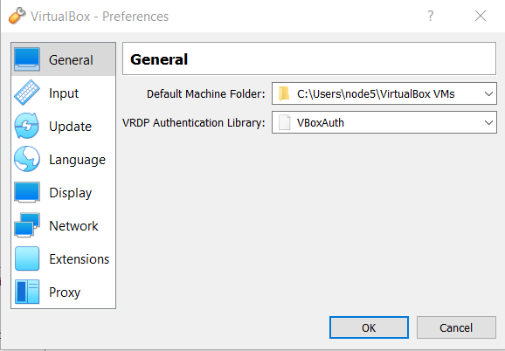

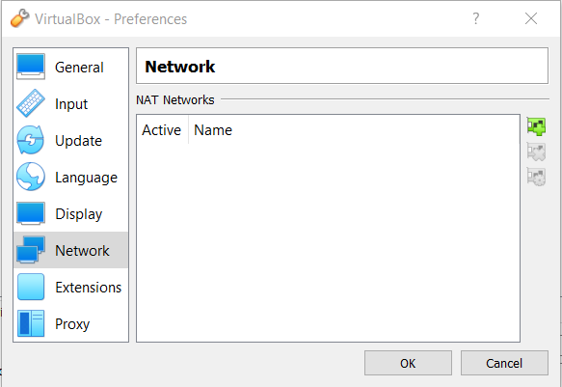

Once in the ‘Network’ tab, click on the green plus icon on the right-hand side. This will create a new Nat Network. Once this is accomplished click on the yellow settings icon on the right-hand side.

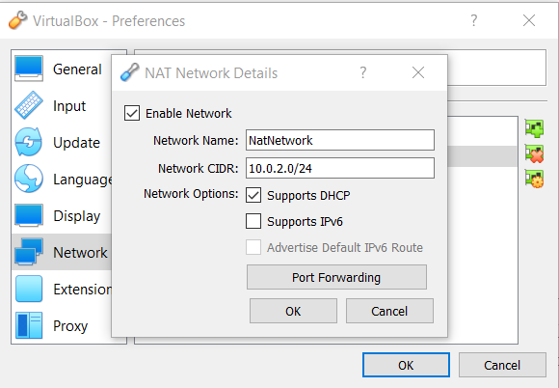

From here you can set the network name and the IP address range. In our case we set it to 10.0.2.0/24. This can be any range you like.

# **Chapter 3: Design**

## Virtual Machine 1

This virtual machine will contain two snapshots, each containing different challenges to test your knowledge in different areas. Each challenge will contain a flag for you to receive if completed.

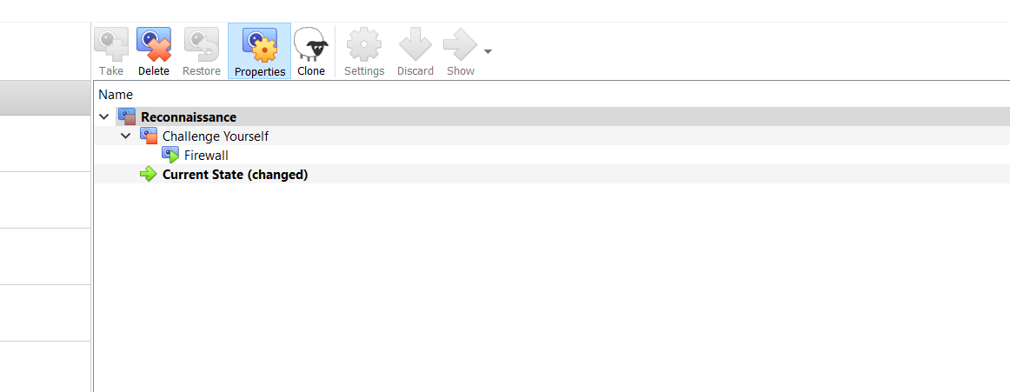

**Snapshot 1**

The first snapshot is mainly about reconnaissance. This will test your ability to gather as much information on a target as possible. Reconnaissance is a process and techniques used to discover information and collect data on a given target. Information gathering is the first step which is carried out in a full penetration test. Information gathered can range from a variety of tasks, such as discover a network IP address range, discover open and closed ports, uncover vital information, which will help in gaining access to the targets machine or data.

Two ports will be open port 80 which will contain a http website and port 443, which will contain the https version of the website. For this snapshot, you are not intended to gain access to the machine. The main aim is to grow your reconnaissance skills, as a penetration tester they have to make sure they thoroughly check the website for as much info as possible.

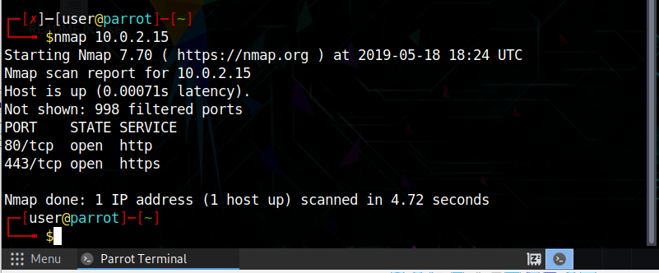

Since you do not need to gain access to the machine in order to find all the hidden flags. You are forced to use reconnaissance skills and navigate to the website where there will be several flags hidden.

**Flag 1:** This flag will be on the website since port tcp/80 and tcp/443 are open. This flag is designed so that the penetration tester is made look at every single detail on the website. In real life scenarios, a lot of sensitive and valuable information could be on the website. This could be as simple as the employee’s names or sensitive information that can be used to gain access to a targets system.

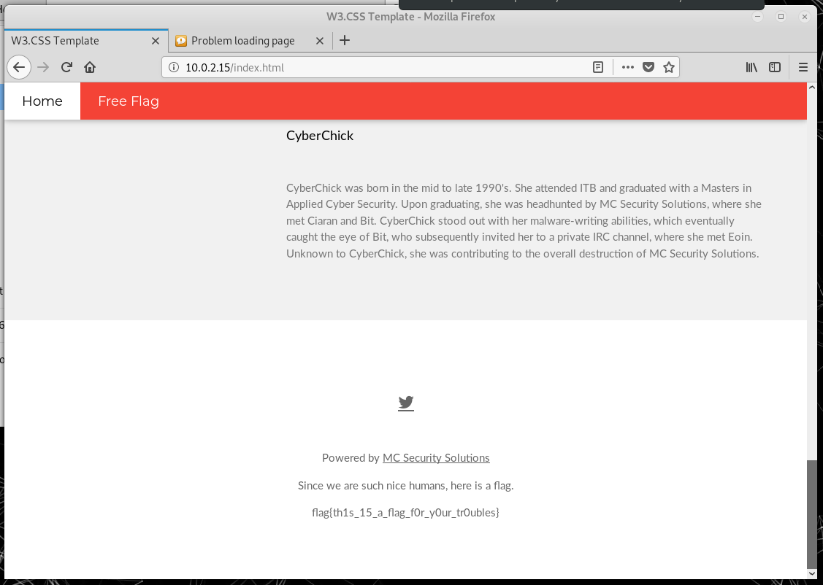

Flag 1 = flag{th1s_15_a_flag_f0r_y0ur_tr0ubles}

**Flag2:** A lot of the time when web developers write their website code, they leave comments. These comments are pieces of text that are ignored by interpreters. They help the developer understand different sections of code or leave tips or notes. In some cases, passwords can be left as a comment and they might have forgotten to delete it. Comments in html, use the syntax of <! --This is a comment→.

In your browser, whether it be Mozilla Firefox or Google Chrome you are able to view the html source code of the website. In Mozilla Firefox and google chrome if you press CTRL+U or you can right click and press the ‘view source page’ button.

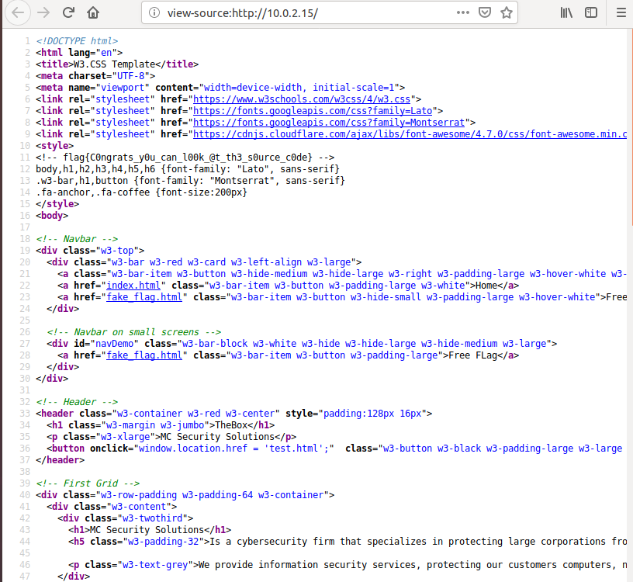

As you can see above, on line 11 there is a comment. The comment is the second flag. This makes sure the penetration tester or student checks the source code. JavaScript is sometimes in the source code of a website, a good penetration tester will examine this code, to check for potential exploits.

Flag 2 = flag{C0ngrats_y0u_can_l00k_@t_th3_s0urce_c0de}

**Flag 3:** Understanding the basic syntax of different programming languages, is very important as a penetration tester. If you can understand the syntax you can figure how the program or script can do. A widely used and popular programming language in the world of cyber security and software development is Python. More specifically Python version 3. Python has an extensive range of libraries that help developer with code, as they are pre-written modules each with a specific aim. Python is also cross platform, which means can be run on the main three operating systems, Windows, Linux and Mac OS.

The third flag is on a different page of the website. If you click on the ‘Join Us’, you will be redirected to different page.

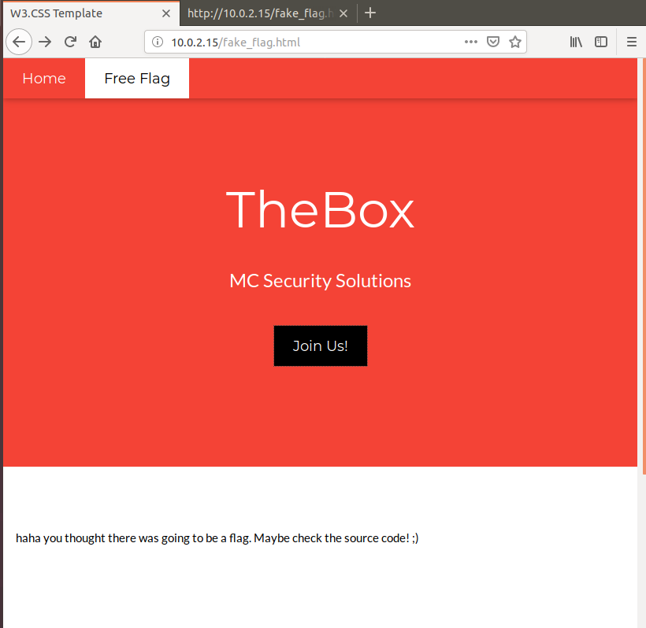

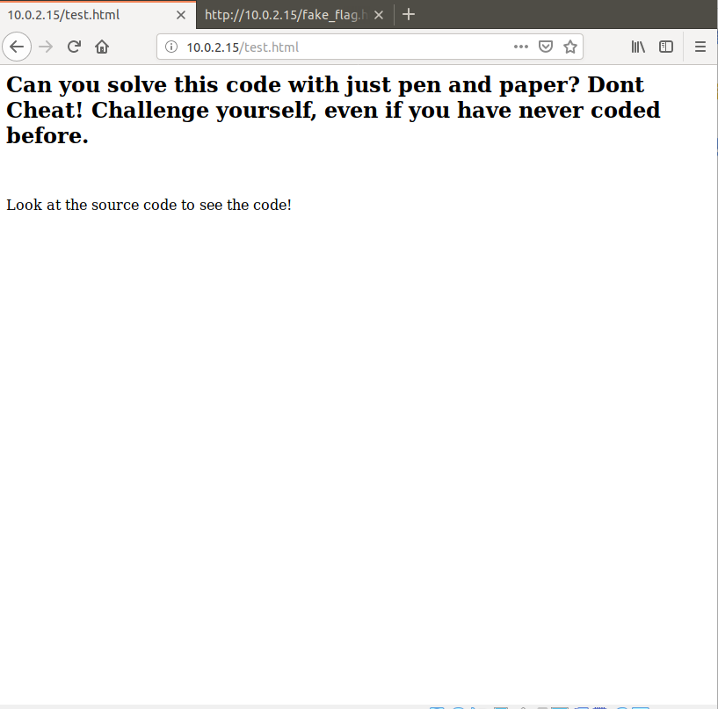

## 

Once again, you can access the source code of this page. As a comment in the source code there is a small python script. Understanding the basic flow of a python script is important as you can quickly glance at some code and have a basic understanding of how it works.

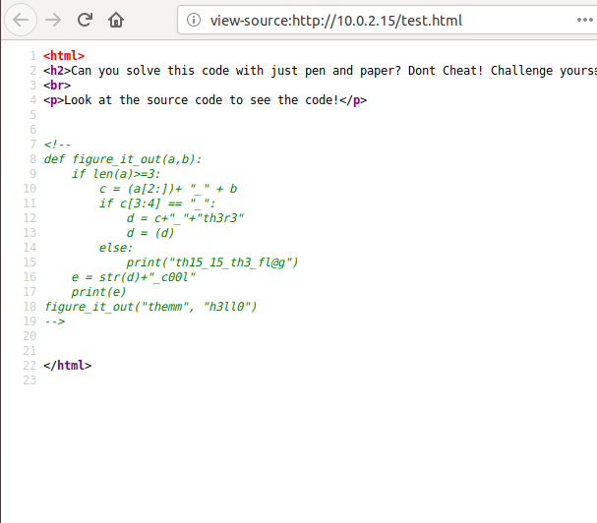

Flag 3 = emm_h3ll0_th3r3_c00l

**Snapshot 2**

This snapshot is a challenge snapshot to see if the student knows their way around a Linux system. Flags are hidden in various locations scattered in different folders and files in a Linux machine. As a penetration tester, Linux operating systems are the best operating system to use. Linux have a wide range of useful penetration testing tools, as well as a bash shell.

This snapshot requires the penetration tester or student to brute force the passwords to gain access to the system. There will be three ports open, port 80 and 443 as well as port 22. Port 22 which is the SSH protocol will be open to try brute force.

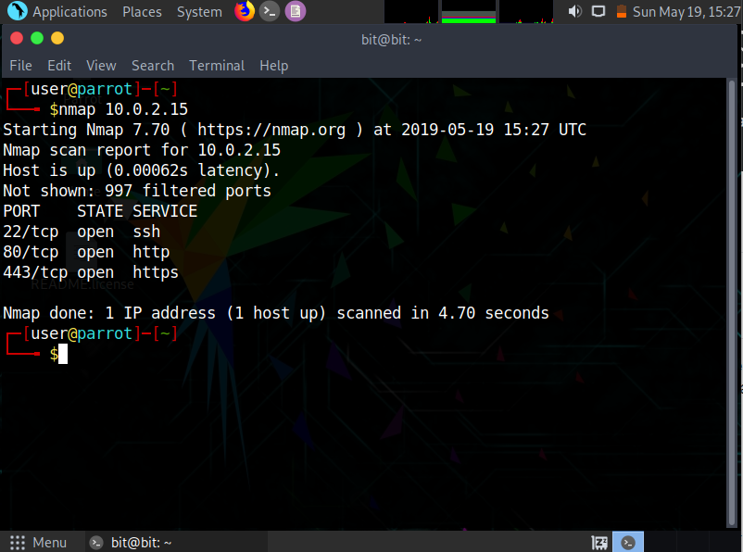

Once you brute force all the users, with the tools of your choice, there will be three flags hidden in the machine. All the passwords will be in the rockyou wordlist.

**Flag 1:** This flag will be hidden in Bits’s home folder. It will be in a dot folder or hidden directory. Hidden directories basically cannot be viewed with just the basic ‘ls’ command. Once you view all the files you will see the ‘. secret’ hidden folder.

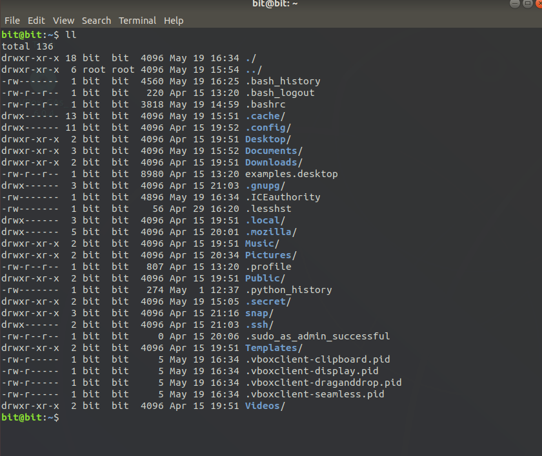

Once you enter into this hidden directory, you will see a text file that contains flag 1.

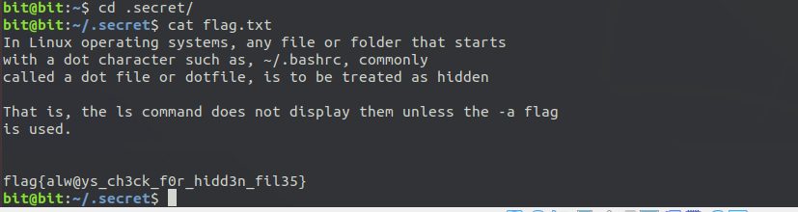

Flag 1 = flag{alw@ys_ch3ck_f0r_hidd3n_fil3s}

**Flag 2:**  Flag 2 will also be in Bits account. This time instead of a hidden directory, it will be a hidden file. The dot file is located in /home/bit/.bashrc

The .bashrc file is a shell script that bash runs whenever it is started interactively. You can put any command in that file that you could type at the command prompt.

Once you scan through all the content of the .bashrc file you will see that there is a custom alias.

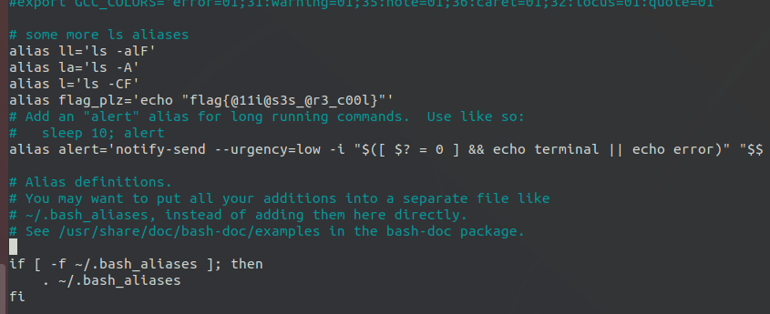

The main function of the alias command is to read commands and execute them. Its sets a command to a certain string. The string is then typed into the terminal instead of the full long command.

As you can see above there is an alias set to ‘flag_plz’. If you type that in the terminal the flag will be printed.

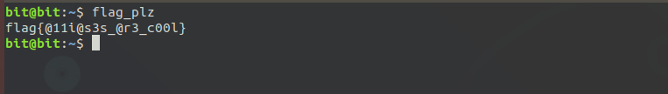

Flag 2 = flag{a11i@s3s_@r3_c00l}

**Flag 3:** This flag is hidden in Ciaran’s account. Again, it will be hidden in a dot directory in ciarans home folder. This time when you open the directory there will be two files. The flag.txt file and a help.txt file.

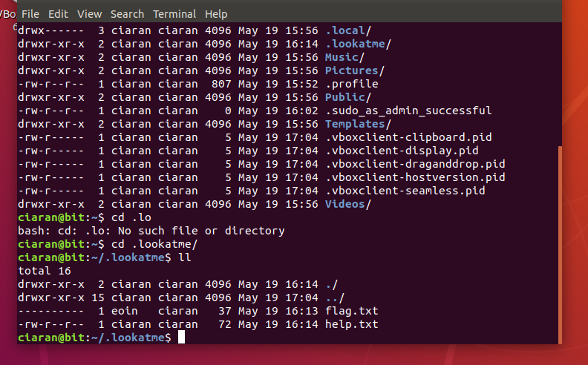

If you try view the flag file, you will be greeted with the prompt of ‘permission denied’. This is because the files permissions are set to non-readable, non-writable and non-executable. Since Ciaran has sudoers permission he will be able to change the permissions with the ‘chmod’ tool.

The help file gives you a hint to look at the file permissions.

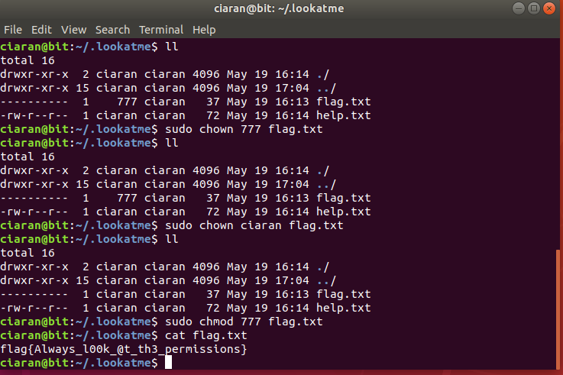

Flag 3 = flag{Always_l00k_@t_th3_permissions}

## 

## Virtual Machine 2

This machine is based around port scanning, port exploitation, and hash breaking. There are four to five flags in each snapshot, with the aim that the student will learn new techniques that can be built upon if they want to work in the professional world of penetration testing.

**Snapshot 1**

This snapshot is aimed at the student learning the basics of port scanning and exploitation. Flags will be in each account, with the intention of the student gathering flags that contain hints to break into the next account.

The student will learn how “file-transfer protocol” (FTP) works, what port it is usually run on, and how they can exploit the port and the service. This will aid in the knowledge of how they can then protect against this vulnerability.

**Flag 1:** The first flag of this box is in the anonymous account. Though anonymous login is disabled by default, companies may enable this for public downloading. It can be read either by browsing to ftp://10.0.2.20, or by accessing the anonymous account using the command line by using the command ‘ftp 10.0.2.20’, then using the get command to download the flag onto the host computer.

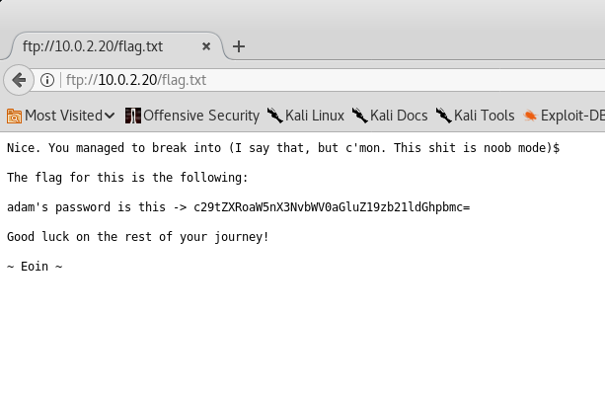

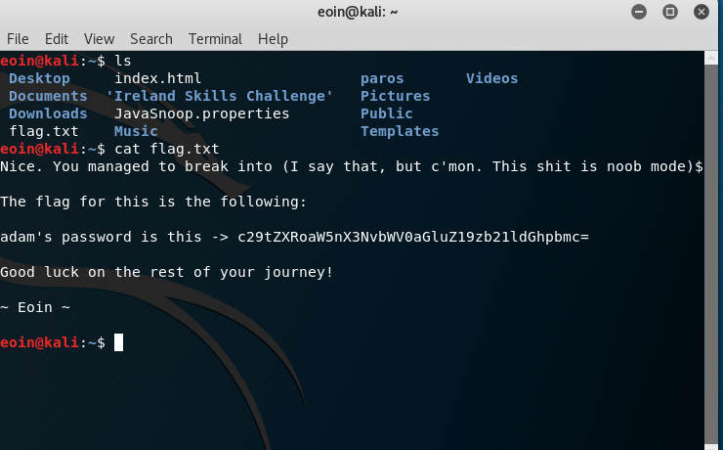

Flag 1: adam’s password is this -> c29tZXRoaW5nX3NvbWV0aGluZ19zb21ldGhpbmc=

**Flag 2:** The second flag for this account is found in adam’s account. The password is obtained by decrypting the flag previously obtained, which is decrypted to ‘something_something_something’. With this, they get a hint to go looking for e0in’s twitter account, and also find the twitter account made for The Box.

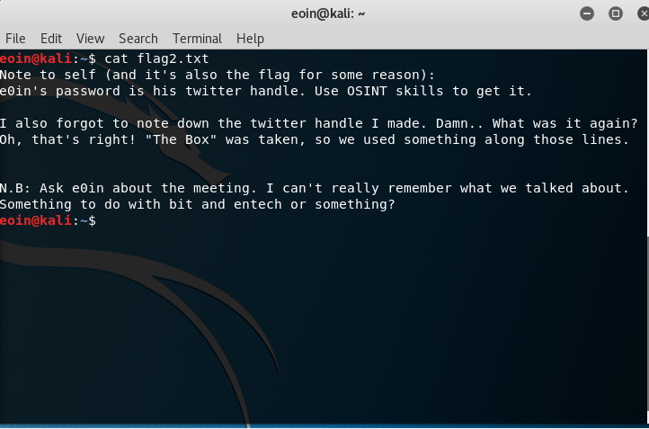

Flag: e0in’s password is his twitter handle. Use OSINT skills to get it

**Flag 3:** The third flag is obtained through e0in’s account. By using some open-source intelligence (OSINT) skills, the student finds the twitter account made by adam (@The_Pentest_Box), and through that, they find e0in’s twitter handle (@th3_L3773r_a). By inputting this as the password, the student gains access to e0in’s account, and gets another flag.

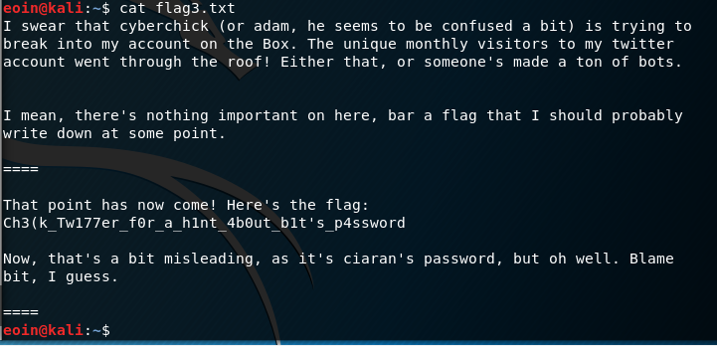

Flag 3: Ch3(k_Tw177er_f0r_a_h1nt_4b0ut_b1t's_p45sw0rd

**Flag 4:** The fourth flag is obtained through ciaran’s account. By using the OSINT skills learned to get the previous flag, the student will find out that bit was killed by Entech in the game ‘Hacknet’. By inputting “bit_was_killed_by_entech” as the password, the student will have gained access to ciaran’s account, and the flag.

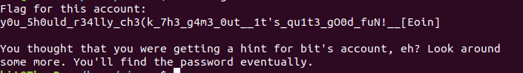

Flag 4: y0u_5h0u1d_r34lly_ch3(k_7h3_g4m3_0ut__1t's_qu1t3_gO0d_fuN!__[Eoin].

The password for bit’s account can be found in a hidden directory, which the student can see using the ‘ls -a’ command. 

Within the .secret folder, there is a text file which shows the password.

**Flag 5:** The fifth flag on this snapshot is found in bit’s account. By obtaining the password from the hidden folder in ciaran’s account, the student can access bit’s account and get the root.txt file, signifying the end of this snapshot.

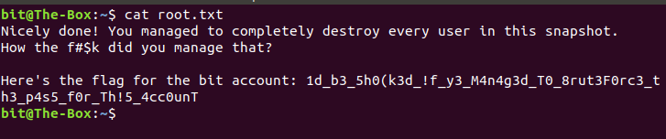

Flag 5: 1d_b3_5h0(k3d_!f_y3_M4n4g3d_T0_8rut3F0rc3_th3_p4s5_f0r_Th!5_4cc0unT

**Snapshot 2**

This snapshot is based around hash breaking. It is aimed to teach the student in how to break hashes, and how to identify the encoding used.

**Flag 1:** The first hash is found in the descrIPtion of the box. It is intended for the student to use a tool like hashcat to break the hash.

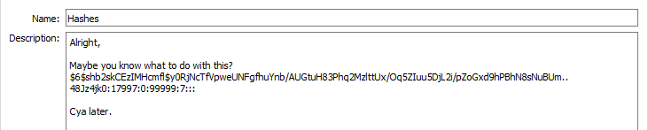

When broken, it gives the text “t00_c0mpl1c4t3d”. This is the password for e0in’s account. In e0in’s account, the student will find their first flag.

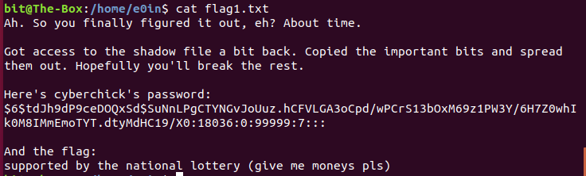

Flag: supported by the national lottery (give me money pls)

**Flag 2:** The same process is used by the student to break the hash for the password of the cyberchick account. The password is “c4nt_b3_4rs3d__l34v3_m3_b3”. Within cyberchick’s account, the student will find the second flag.

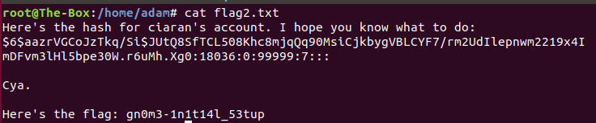

Flag: gn0m3-1n1t14l-53tup

**Flag 3:** The student will now break the hash given from the previous flag, eventually getting “1m_4_wh1t3_h4t” as the password. Accessing ciaran’s account will give the student the next flag.

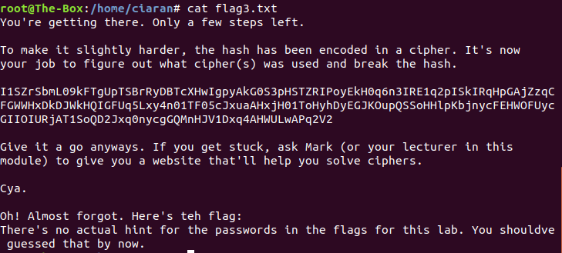

Flag: There’s no actual hint for the passwords in the flags for this lab. You shouldve guessed that by now.

**Flag 4:** The hash has been encoded twice using the ROT13 alphabet. When the string has been decoded fully and the hash has been broken, the student will gain the root password ‘Try_us1ng_4n_4ctu4l_w0rd-l1st’. Using this password on the remaining bit account, the students has gained root to the system. The final flag of this snapshot can be found in the home folder of bit.

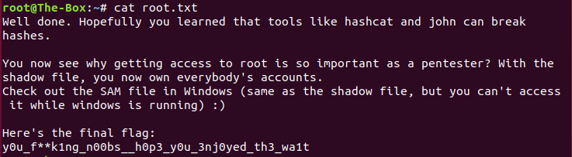

Flag: y0u_f**k1ng_n00bs__h0p3_y0u_3nj0yed_th3_wa1t

## Virtual Machine 3

The third virtual machine contains the following two snapshots: SSH and CIPhers. Within each snapshot there’s a collection of flags. Each flag will be numbered so the student will know what flags they have and what they still need to get.

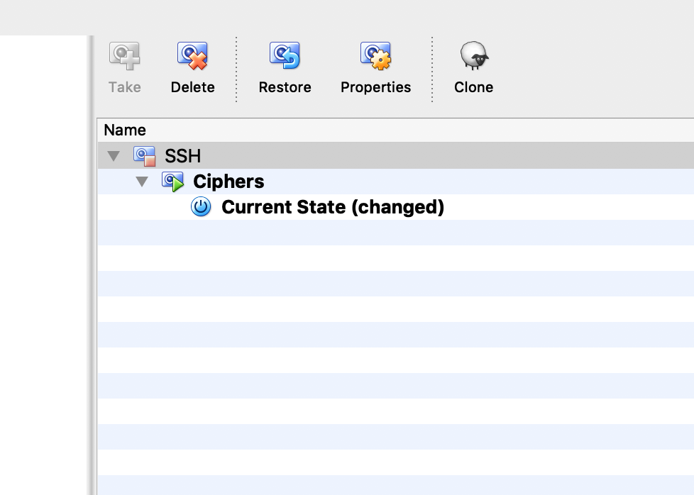

**Snapshot 1**

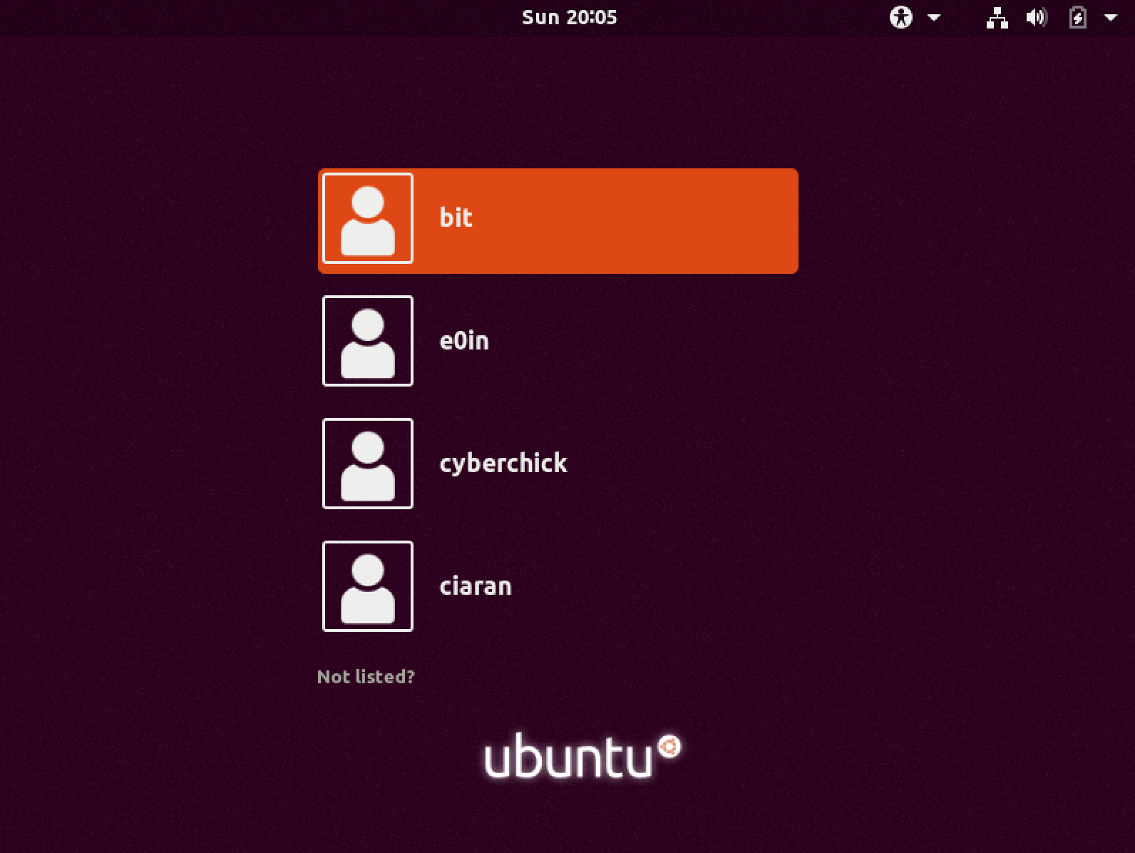

The above screenshot shows the list of users on the target machine for which the target will have to exploit.

The focus for this snapshot is to learn about SSH and apply this knowledge into collecting the hidden flags. The SSH protocol is a method which involves gaining remote access from one computer to another through port 22. In order to do this port 22 must be open on the target machine. There’s a simple command one could use to scan the targets IP to check whether port 22 is open or not.

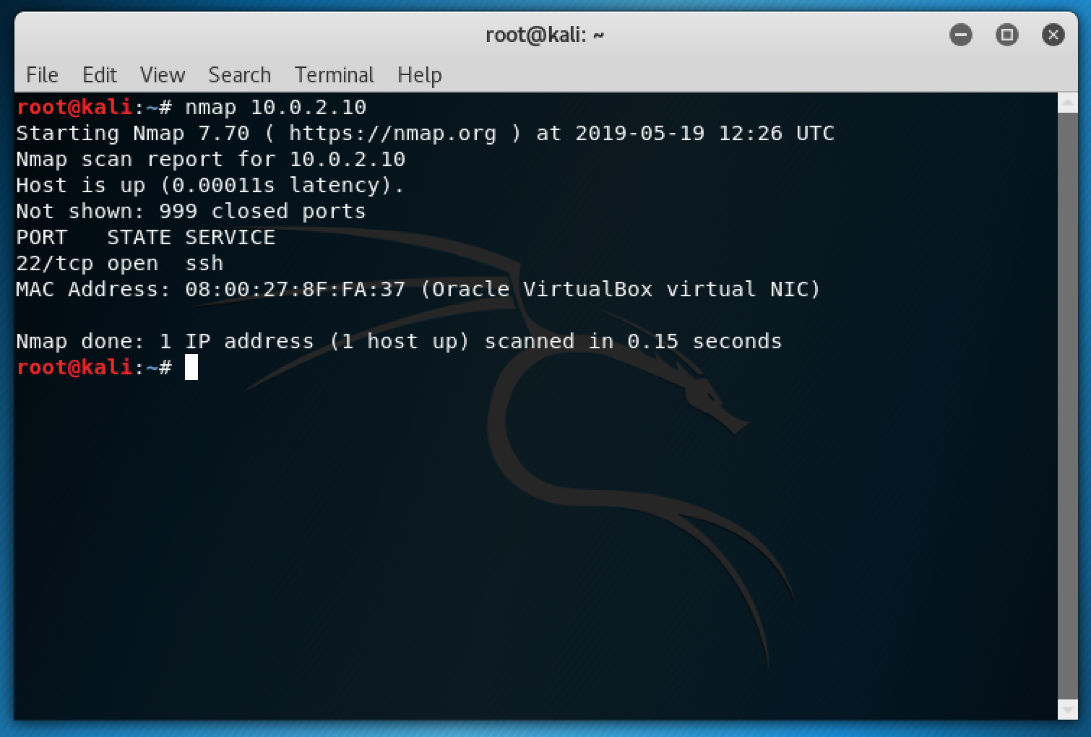

The command needed can be seen in the screenshot above. All you have to do is open a terminal in kali and type in Nmap followed by the targets IP:

Nmap 10.0.2.10

Now that the penetration tester knows the SSH port is open the next step would be to try and brute force the login for each user account to see if it’s possible to gain access.

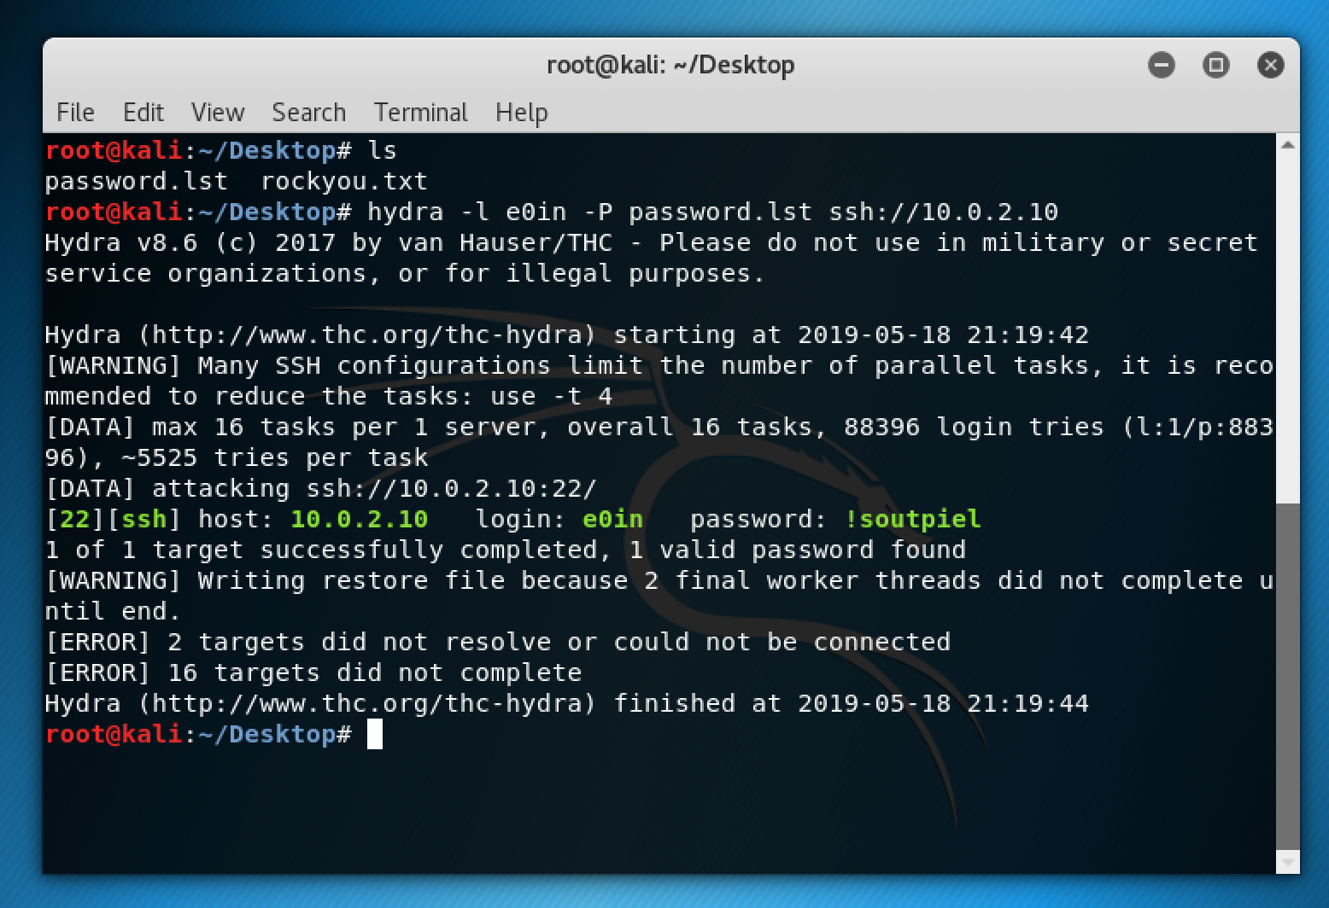

Out of all the users only three of them can be brute forced. But in order to make it slightly difficult there’s two different wordlists used. For the user Eoin the world list password.lst was chosen. The reason for this is that the wordlist rockyou.txt is the most commonly used wordlist.

As seen in the screenshot the command to run the brute force attack is as follows

hydra -l e0in -P password.lst SSH://10.0.2.10

Once the exploit is finished, you’ll be presented with the username and password of the exploited user.

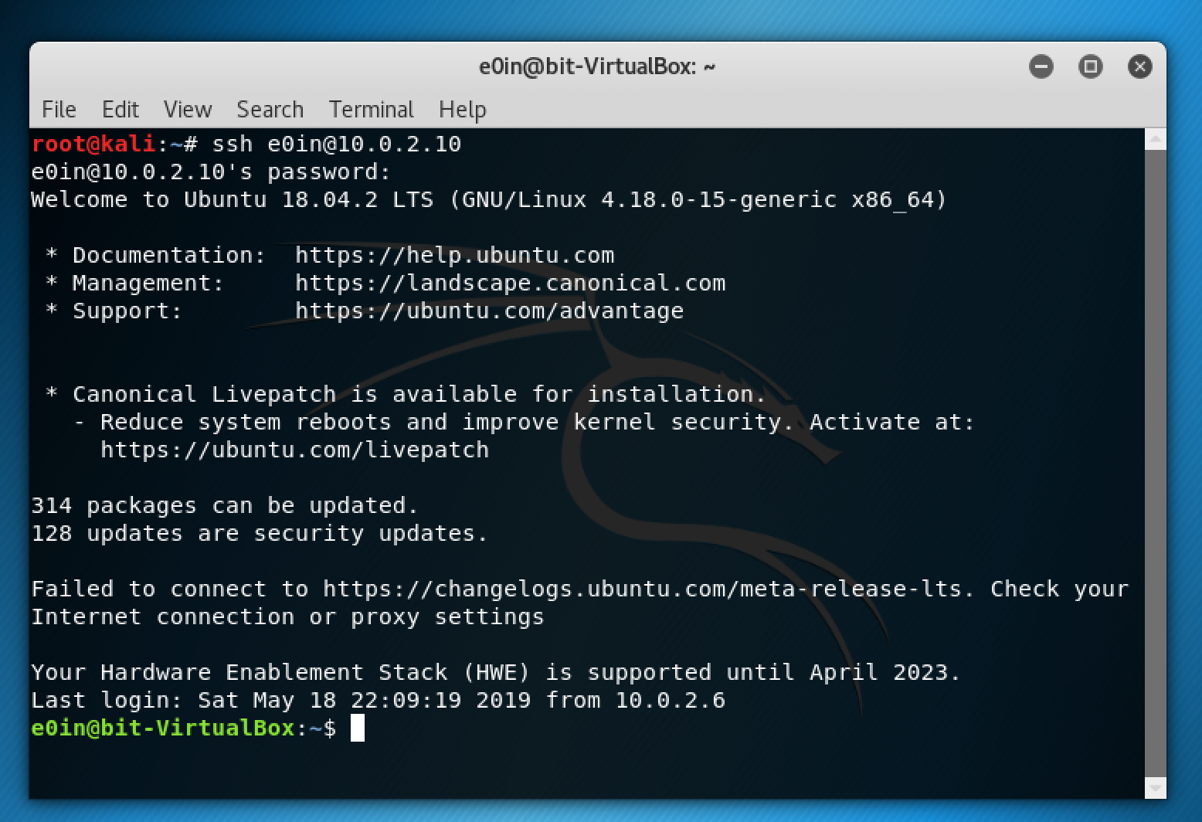

Now that you have both the username and password it’s time to gain remote access to the machine through the user e0in with the command:

SSH e0in@10.0.2.10

The command will be the same for gaining access to each user. The only thing you have to change is the username.

We know the connection was successful as we are now the user e0in. It’s now time to navigate through the directories to find the hidden flag.

e0in@bit-VirtualBox:~$

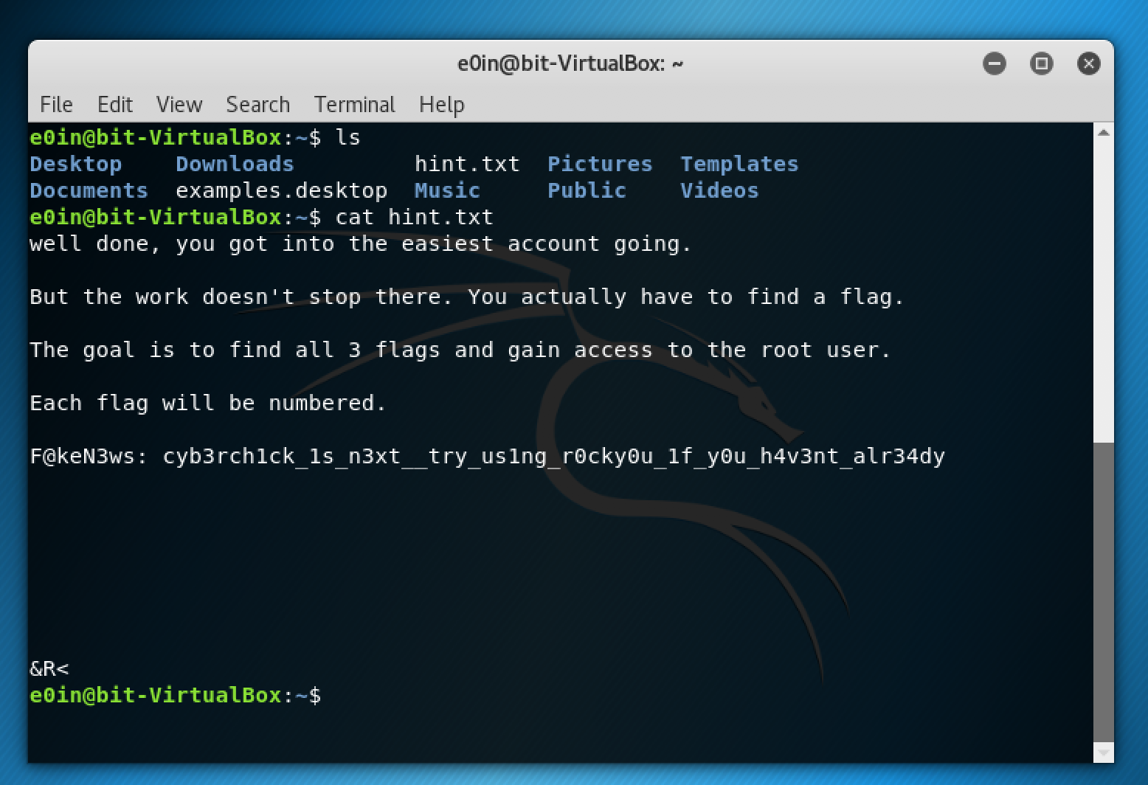

After navigating through the different directories, the penetration tester should eventually find a file named hint.txt. When opened they’ll realise there’s no flag hidden inside of the user e0in but it’s important for the penetration tester to try and gain access to every user as there’s information within each that will help them towards gaining access to the root user.

The hint file as the name suggest will give the student a hint towards the next step.

**Flag 1:** After following the hint the penetration tester should find themselves brute forcing the user cyberchick. The difference between this brute force and the last is the wordlist used. This time round the wordlist rockyou is needed to figure out the password.

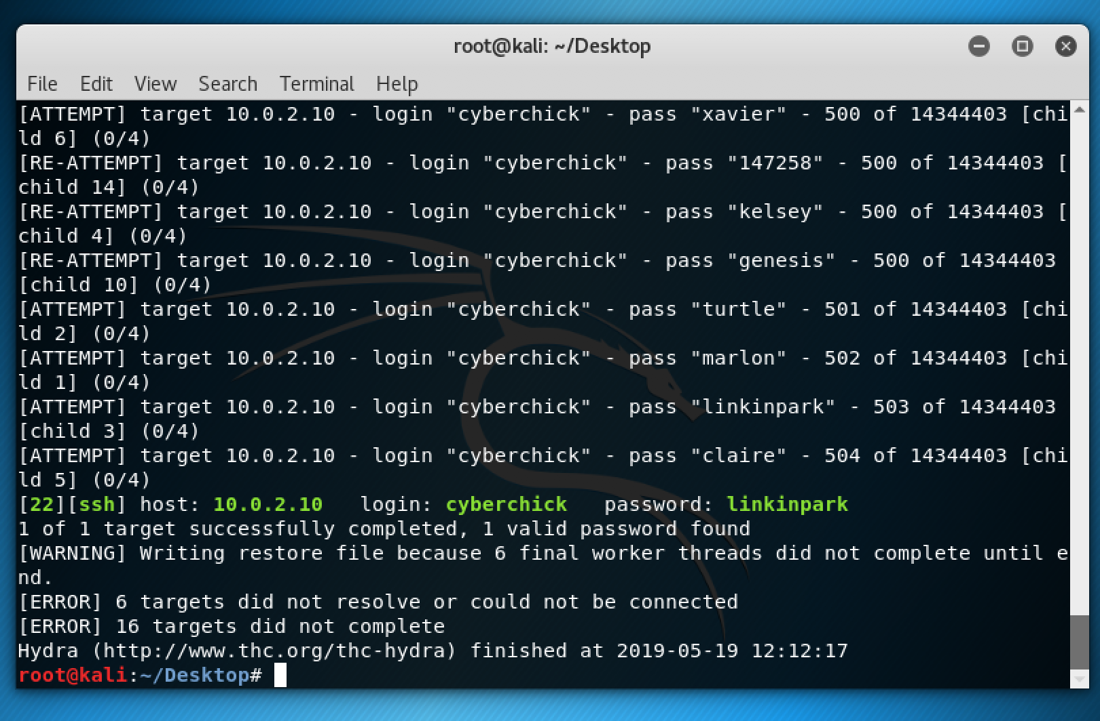

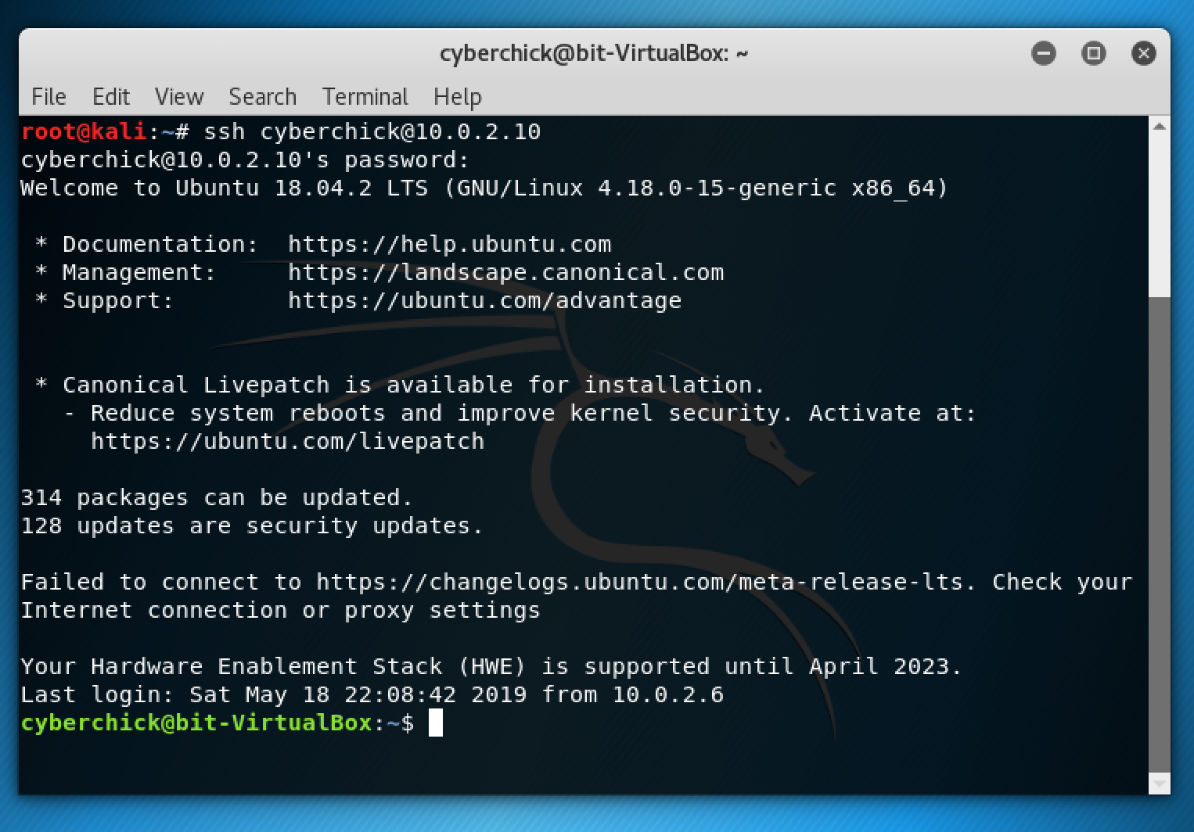

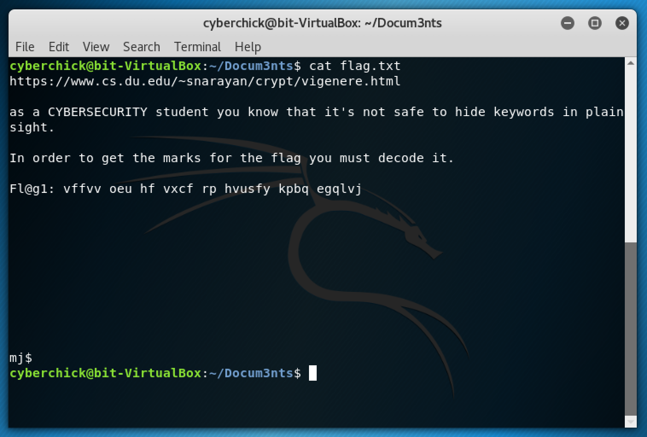

Fl@g1: vffvv oeu hf vxcf rp hvusfy kpbq egqlvj

The penetration tester will need to decode the given cipher in order to be awarded the marks for finding the flag.

**Flag 2:** Once again the rockyou wordlist is used to brute force the user ciaran. With this information the penetration tester can move on to finding the second flag and getting a hint towards finding the third and final flag of this snapshot.

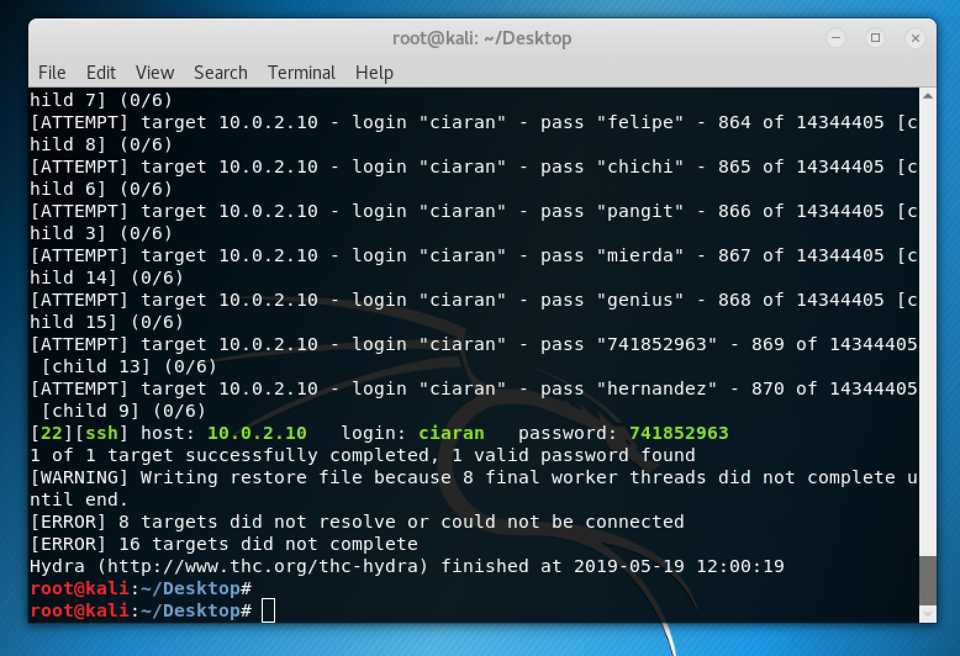

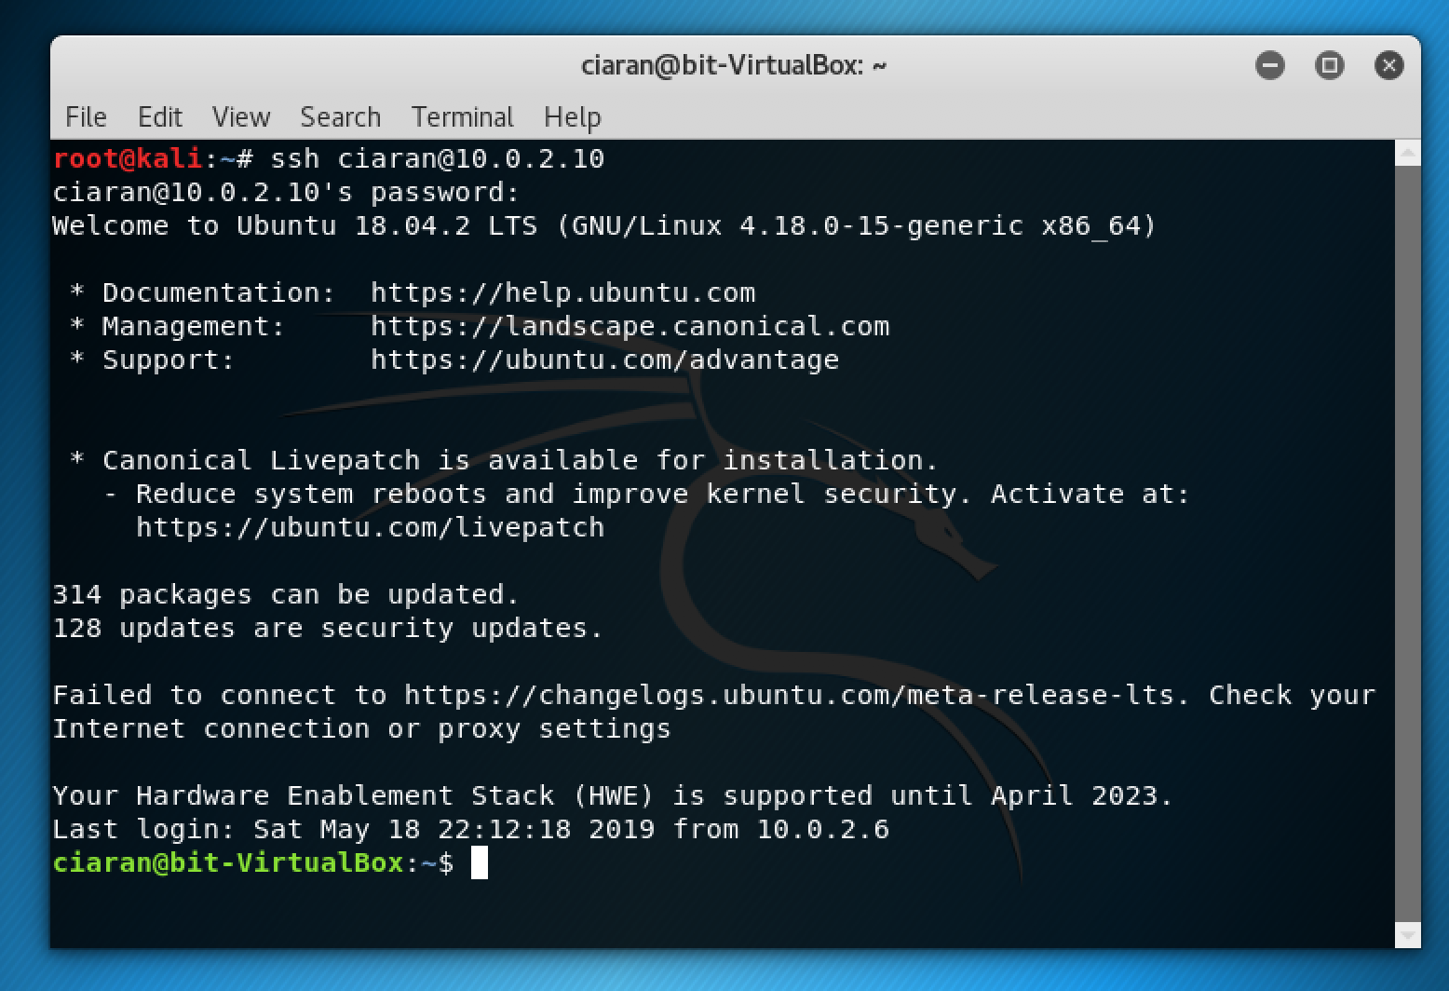

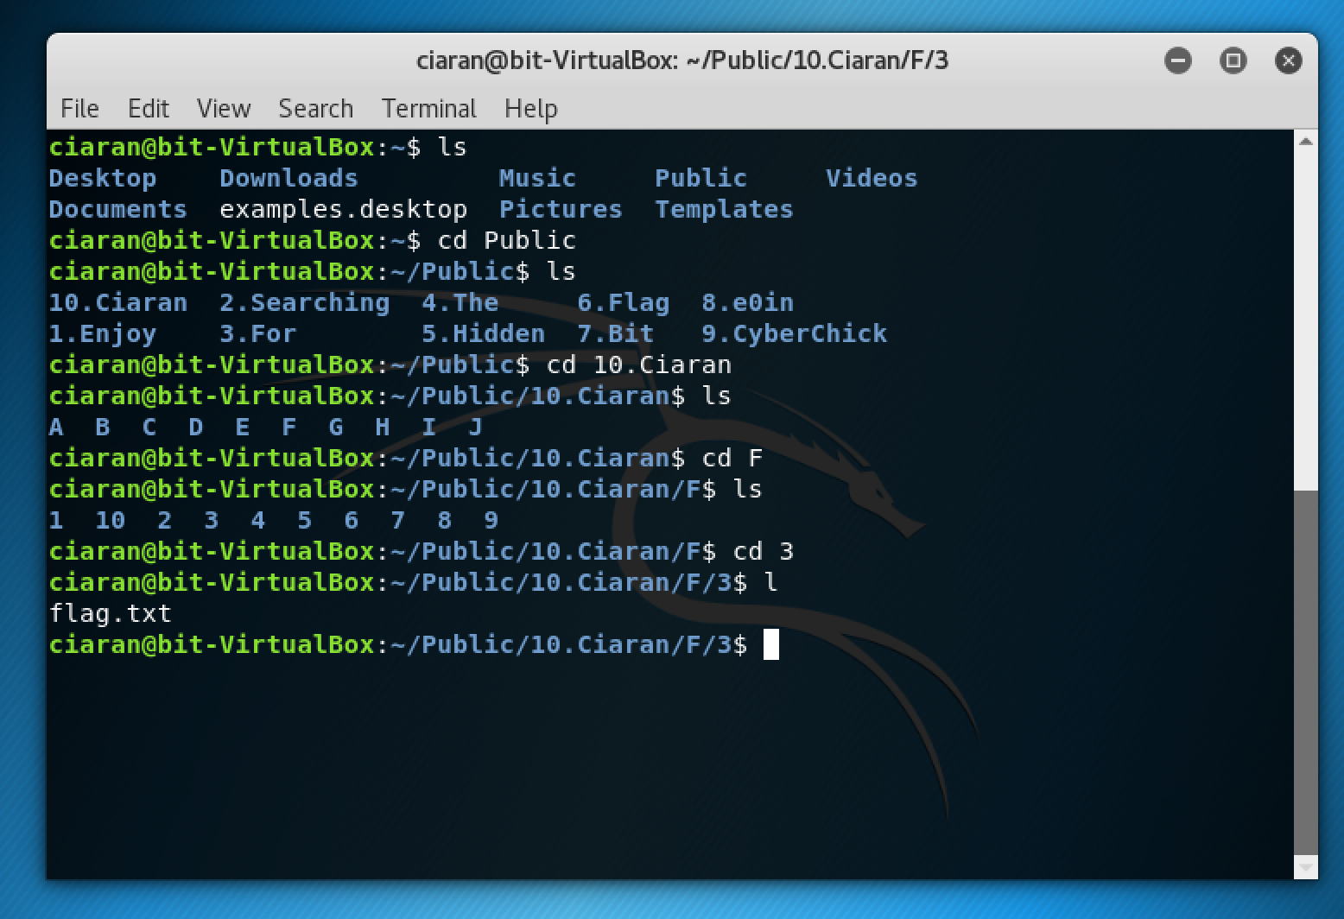

Unlike the other users ciaran has multiple subdirectories making it more challenging for the penetration tester to find the second flag.

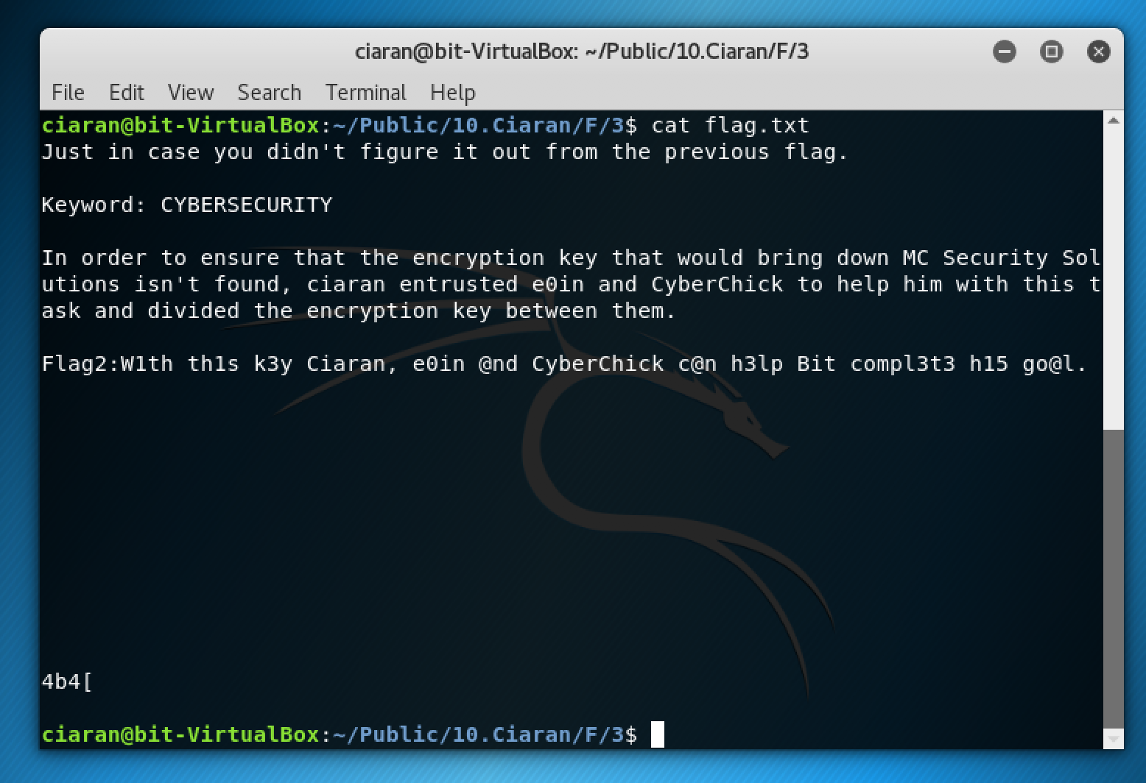

Flag2: With this k3y Ciaran, e0in @and CyberChick c@n h3lp Bit compl3t3 hi5 go@l.

Eventually the penetration tester will stumble upon the second flag. The second flag also has a connection to the first flag as there was a Vigenère cipher that needed to be decoded within the first flag.

Vigenère ciphers use a keyword when encoding/decoding plaintext. In this case cybersecurity is the chosen keyword. This was seen in the first flag, but the second flag provides the penetration tester with more help just in the off chance they missed it.

**Flag 3:** The final user the penetration tester will have to gain access to the root user bit. To access root, you can’t brute force it. Within ciarans flag.txt file it states that ‘in order to ensure that the encryption key that would bring down MC Security Solutions isn’t found, ciaran entrusted e0in and cyberchick to help him with this task and divided the encryption key between them.’

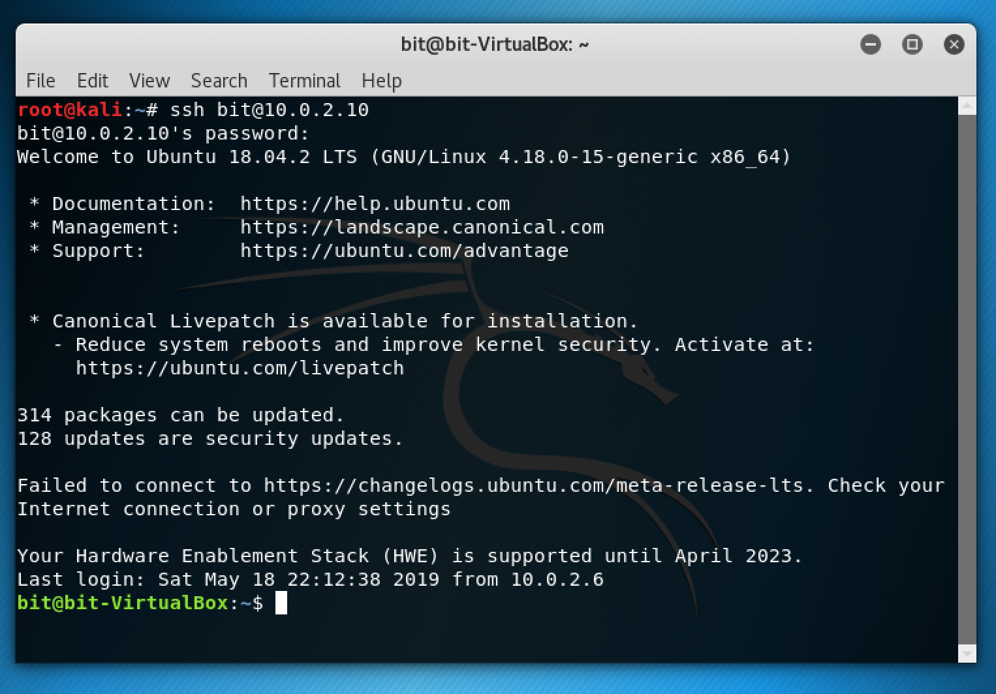

This is said in the hope of helping the penetration tester to realise that sections of the root password is spread out between the other users.

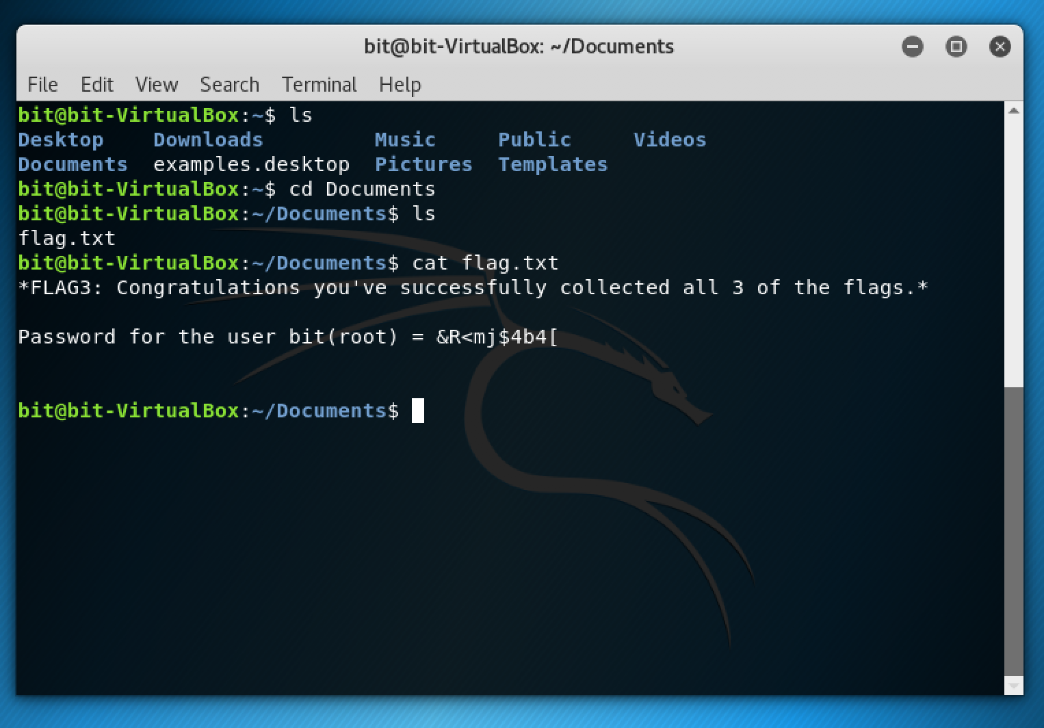

*Flag3: Congratulations you’ve successfully collected all 3 of the flags.*

Once the flag.txt file is opened while as the user bit, you’ll see the contents of the above screenshot. The complete password for the root user is shown.

**Snapshot 2**

The second snapshot follows a similar layout to that of the first snapshot. The main difference between them is that the second snapshot centres more around challenges. You also have to find hidden flags just like the first snapshot but this time there’s more to it.

As well as further developing your skills with SSH, brute forcing and be more comfortable with navigating through directories on a terminal, this snapshot introduces some cipher and binary challenges. There are four flags in total to collect throughout this snapshot.

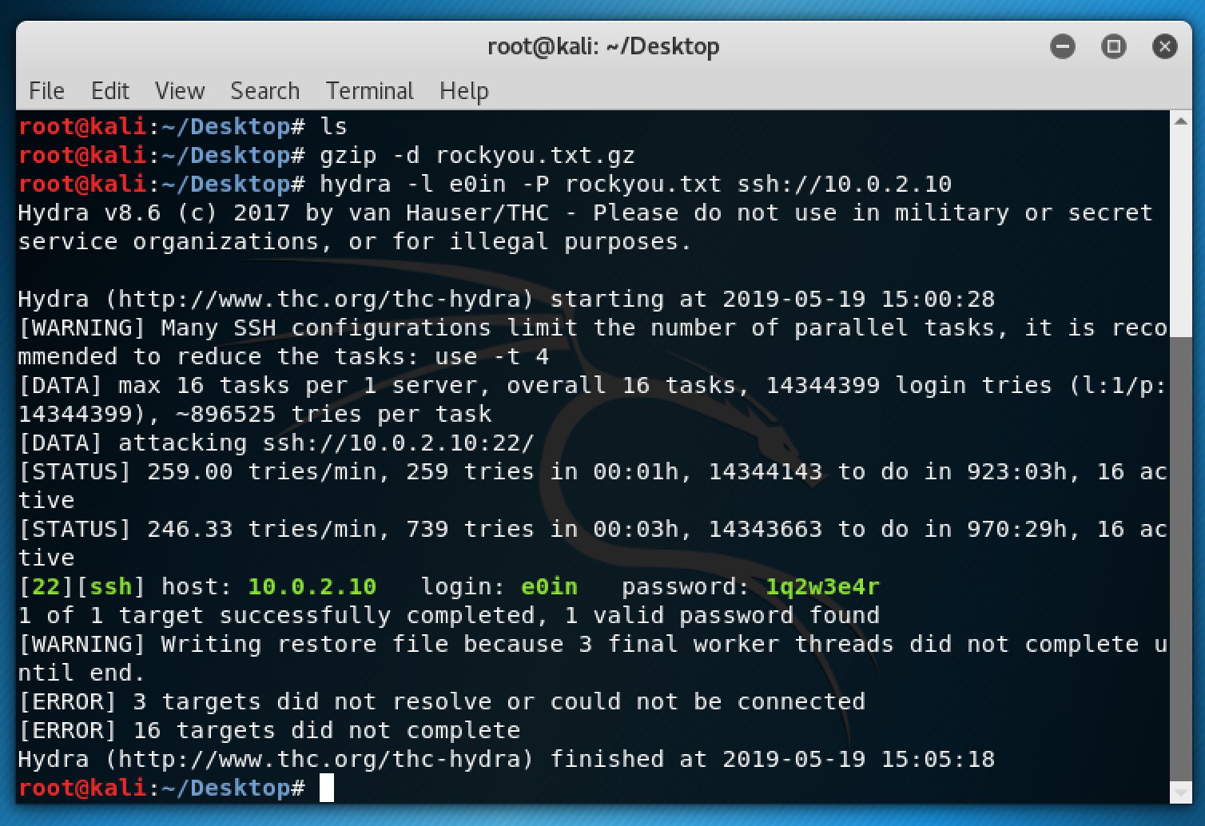

Just like in the first snapshot the penetration tester will have to brute force the users to see which one they can access.

Eoin is the first user that the penetration tester must brute force so they can start collecting flags.

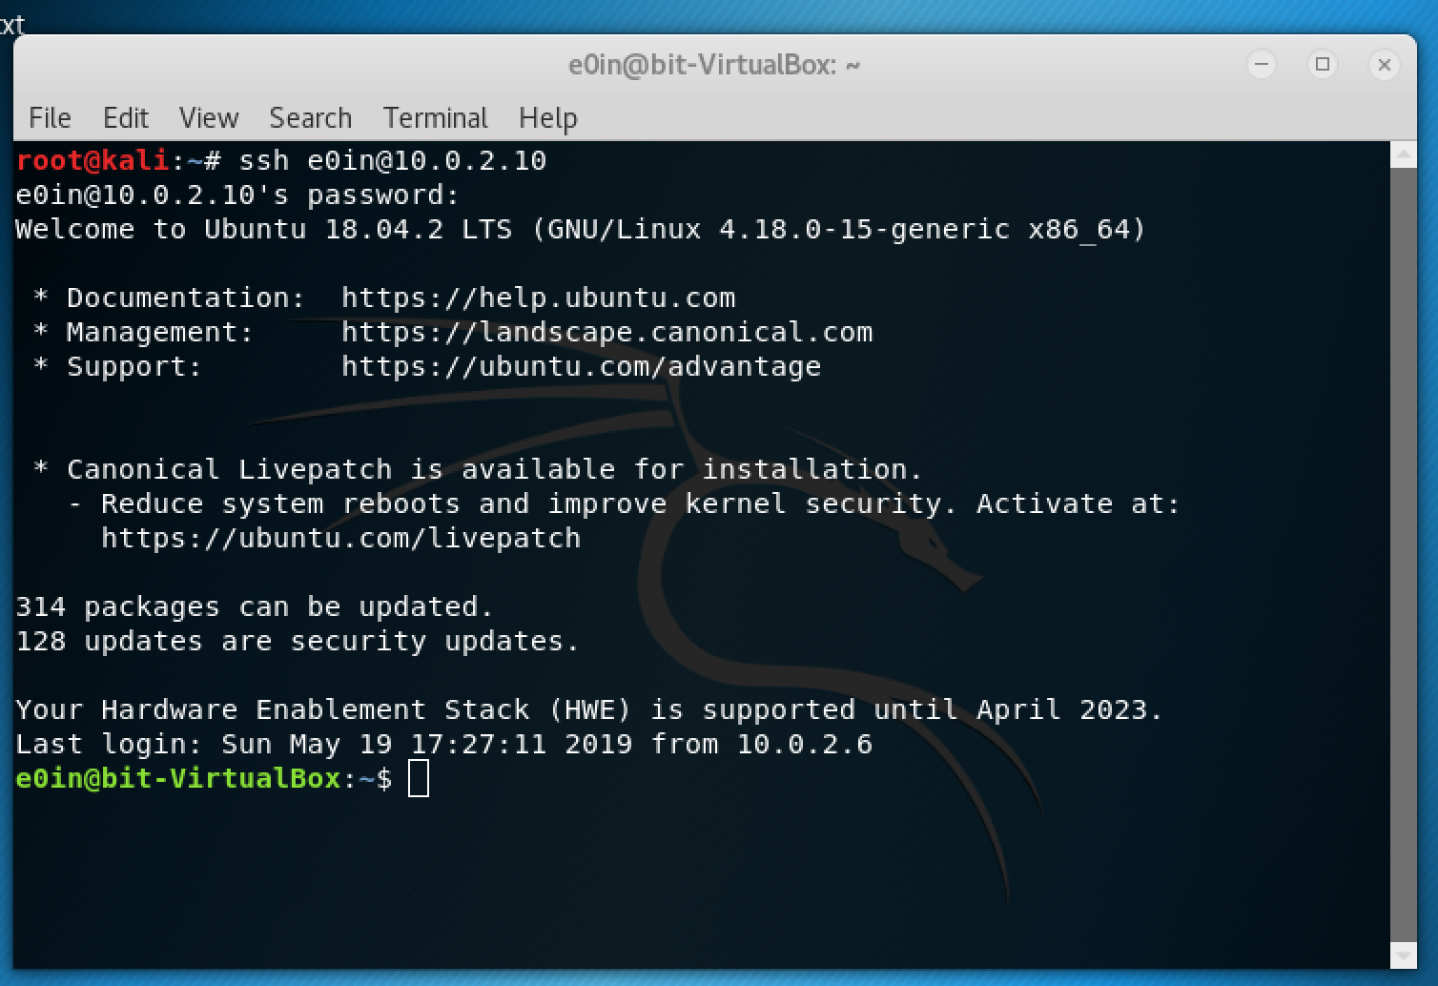

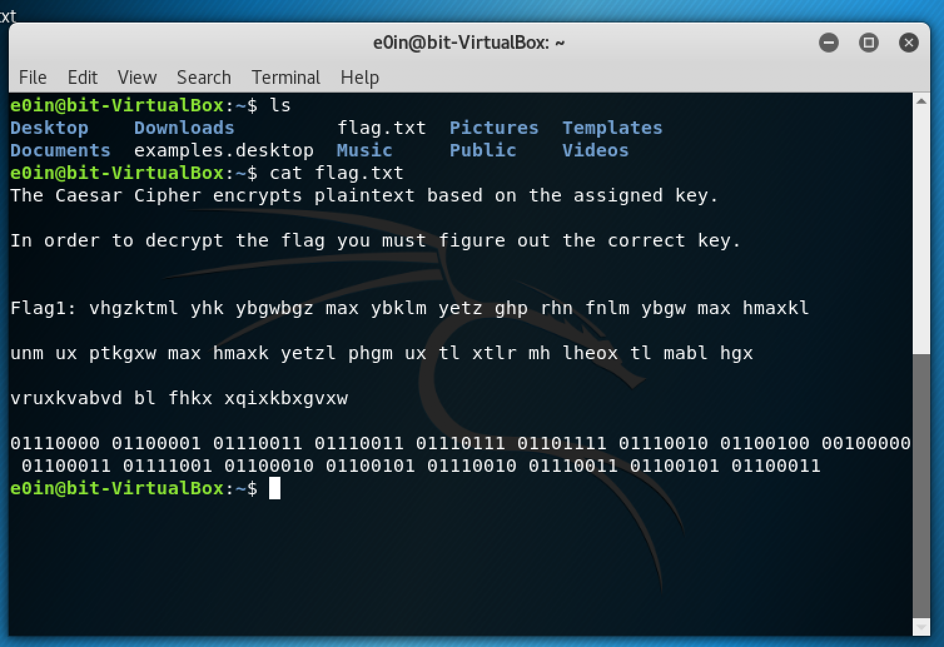

Flag1: vhgzktml yhk ybgwbgz max ybklm yetz ghp rhn fnlm ybgw max hmaxkl unm ux ptkgxw max hmaxk yetzl phgm ux tl xtlr mh lheox tl mabl hgx vruxkvabvd bl fhkx xqixkbxgvxw

To earn the flag the penetration tester must find the correct key to decode the flag.

There is also some binary within the flag.txt file that may help them get the next flag.

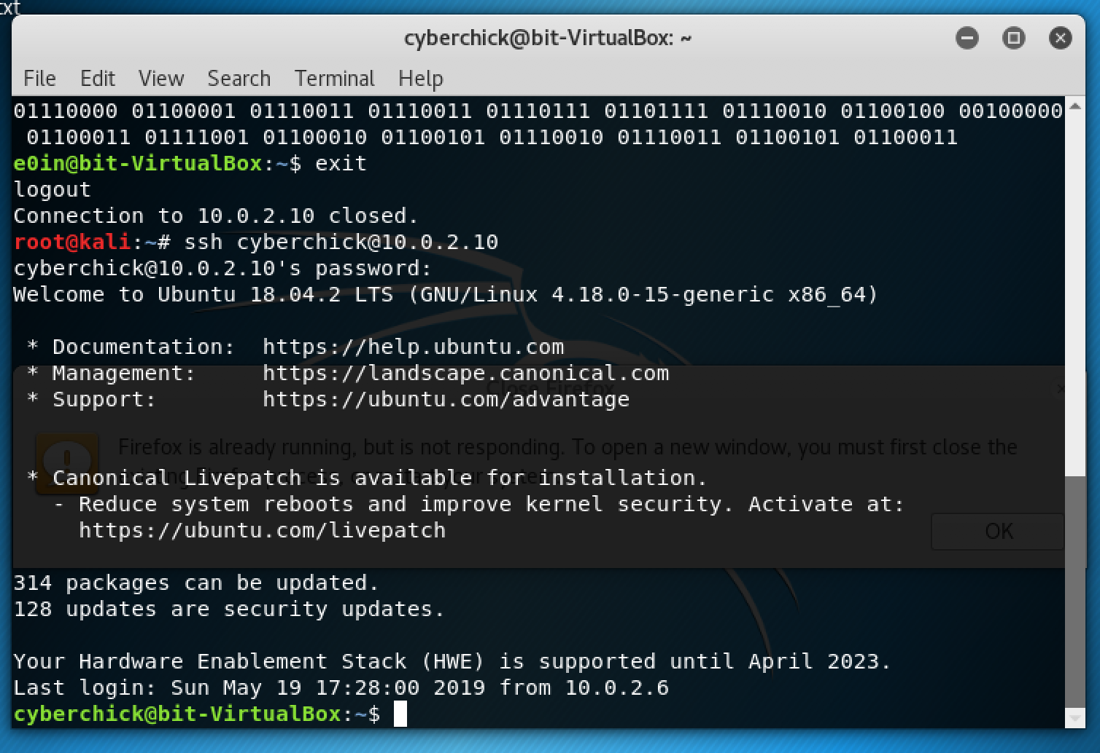

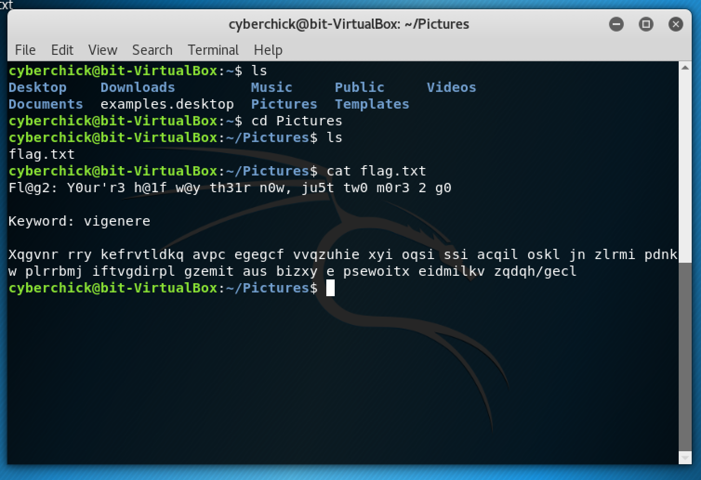

Fl@g2: Y0u’r3 h@lf w@y th3ir n0w, ju5t tw0 m0r3 2 g0

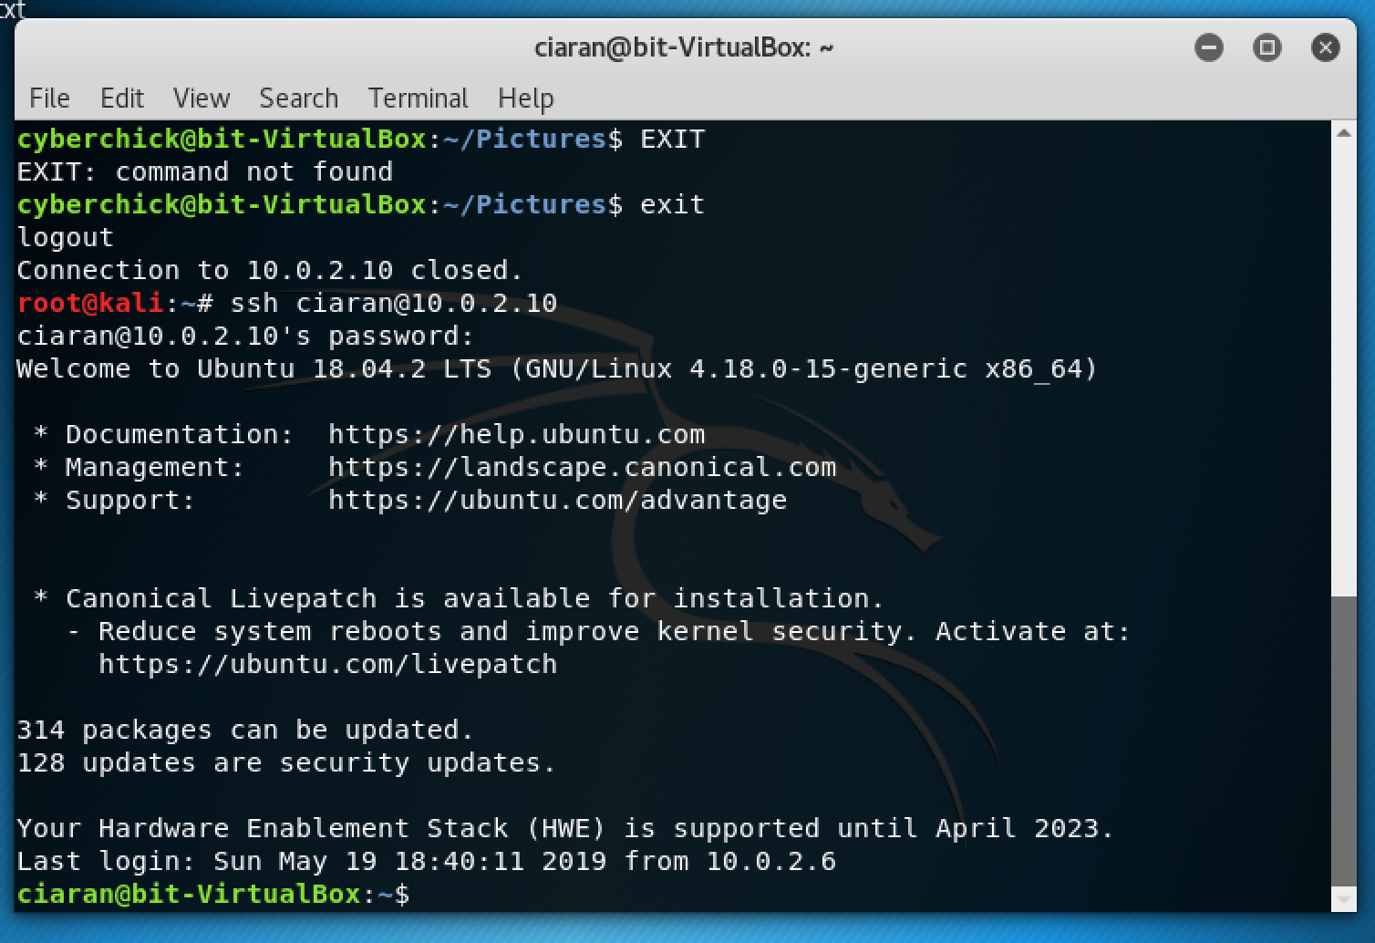

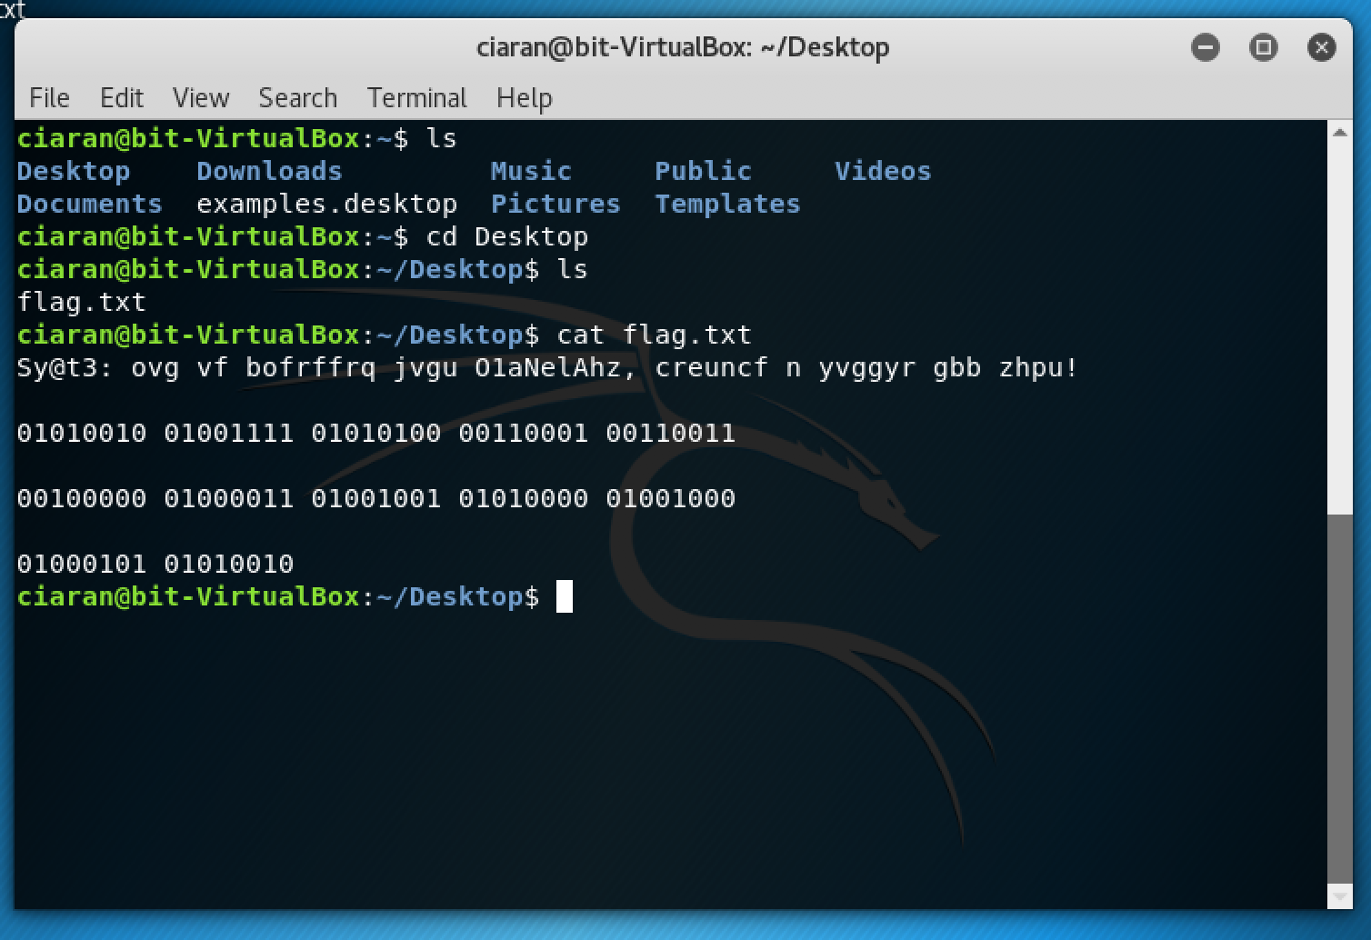

Just like with the other flags you’ll have to decode the flag in order to get

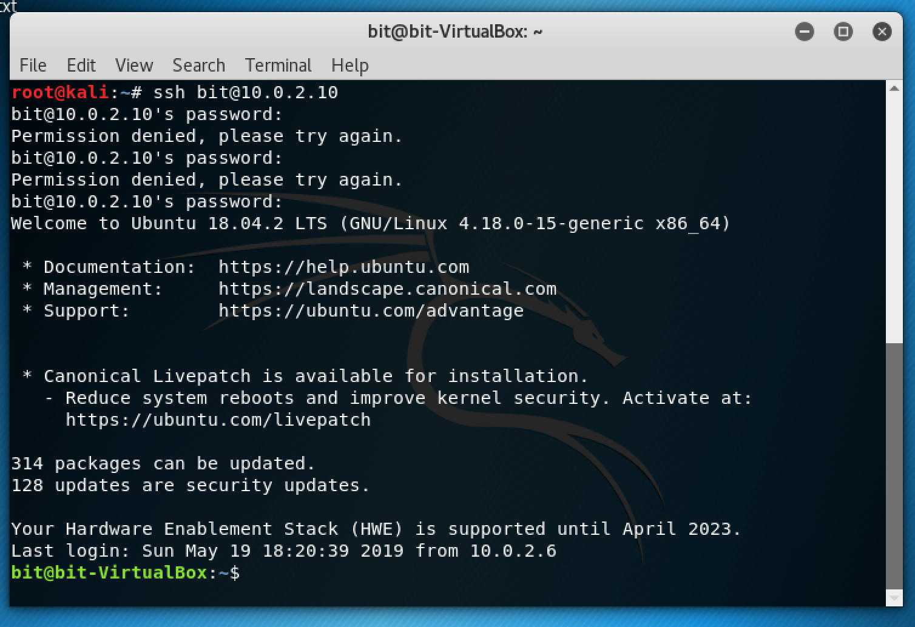

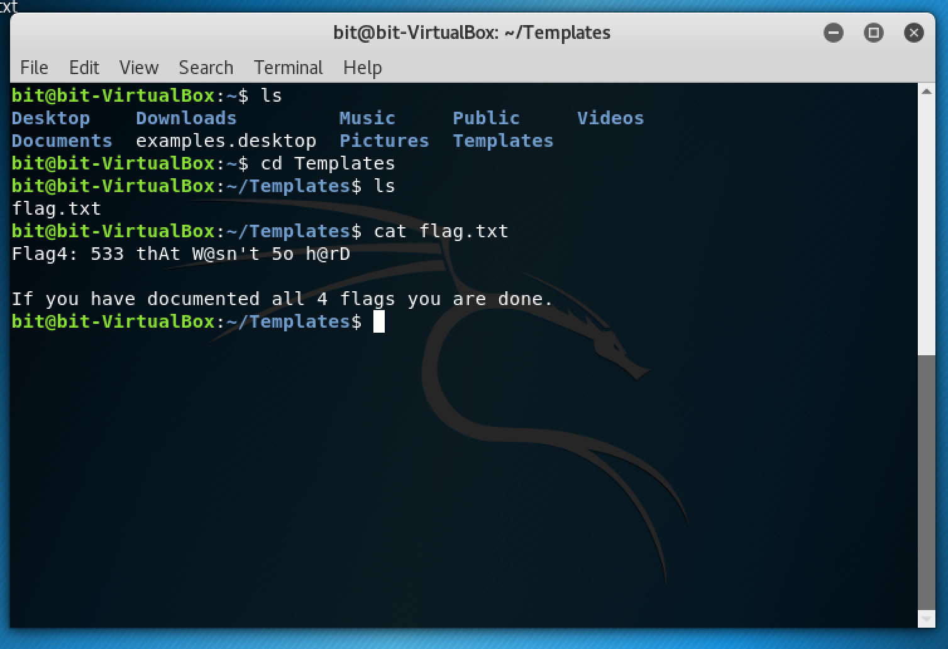

# 

Flag4: 533 thAT w@sn’t 50 h@rD

# **Chapter 4: Conclusion**

In today’s world the use of computers is expanding, from large companies to normal households. Since a lot more people have multiple machines, there is a major need for increase in security. Millions of people and companies get hacked daily, resulting in lots of money or personal data being lost.

The only way to defend against these attacks is to immerse and educate people in the world of penetration testing and cyber security. Learning the basics helps people understand how the basics of many protocols and security mechanisms work. Having a basic understanding will help people understand how an attack was organised and executed.

The purpose of this box is to educate the student or penetration tester in the world of ethical hacking. Each machine and snapshot tests the student in a wide variety of challenges and tasks, ranging from reconnaissance to brute-forcing attacks.

The student should have a fair idea of how to decipher riddles and ciphers and use different tools to brute force SSH and FTP passwords or passphrases.

These machines and snapshot also allow the student to have a testing environment to practice new tools or methods of security and ethical hacking.

In conclusion, students and penetration testers need to expose themselves to new security methods daily due to brand new and commonly seen attacks happening at a faster and faster pace.

# **Chapter 5: References**

Infosec Institute, How to Make Your Own Penetration Testing Lab, [Online] https://resources.infosecinstitute.com/how-to-make-your-own-penetration-testing-lab/

Hostinger.com, [Online] https://www.hostinger.com/tutorials/IPtables-tutorial

DigitalOcean.com, [Online] https://www.digitalocean.com/community/tutorials/IPtables-essentials-common-firewall-rules-and-commands#generally-useful-rules

DigitalOcean.com, [Online] https://www.digitalocean.com/community/tutorials/how-to-implement-a-basic-firewall-template-with-IPtables-on-ubuntu-14-04#an-explanation-of-our-general-firewall-strategy

DigitalOcean.com, [Online] https://www.digitalocean.com/community/tutorials/how-to-set-up-a-firewall-using-IPtables-on-ubuntu-14-04

TrillSecurity.com, [Online] https://www.trillsecurity.com/tutorials/building-a-vulnerable-vm-for-students/

Ehikoya.com[Online] https://ehikioya.com/moving-virtualbox-vm-snapshots/

OsRadar.com, [Online] https://www.osradar.com/how-to-configure-a-firewall-on-ubuntu-18-04/

CyberCiti.biz [Online] https://www.cyberciti.biz/faq/how-to-configure-ufw-to-forward-port-80443-to-internal-server-hosted-on-lan/

Tecmint.com, [Online] https://www.tecmint.com/install-ftp-server-in-ubuntu/

HowToForge.com, [Online] https://www.howtoforge.com/tutorial/how-to-install-and-configure-vsftpd/

OsTechnix.com, [Online] https://www.ostechnix.com/configure-apache-virtual-hosts-ubuntu-part-1/

Ubuntu.com, [Online] https://tutorials.ubuntu.com/tutorial/install-and-configure-apache#2

Keith Sheridan, (2013, May) A Mobile Tracking Web Application for Android, Technological University Dublin (Blanchardstown Campus), [Accessed: May 2019]

Linuxize.com, [Online] https://Linuxize.com/post/how-to-enable-SSH-on-ubuntu-18-04/

UbuntuHandbook.com, [Online] http://ubuntuhandbook.org/index.php/2014/09/enable-SSH-in-ubuntu-14-10-server-desktop/

SecurityOnline.info, [Online] https://securityonline.info/collection-great-wordlist-for-brute force-attackwordlist-brute force-attackword-list-downloads/

UbuntuHandbook.com, [Online] http://ubuntuhandbook.org/index.php/2014/09/enable-SSH-in-ubuntu-14-10-server-desktop/

SpiceWorks.com, [Online] https://community.spiceworks.com/topic/319222-forward-port-80-to-two-different-servers

Exploit Database, [Online] https://www.exploit-db.com/